**The Nuclear Atom**

Radioactivity:

Radiation that comes from the nuclei of an atom

Radiation:

Energy transferred through an empty space

**Ionising Radiation:**

* Is high-energy radiation
* That can affect the electrons surrounding an atom so that a charged ion is formed
* Includes alpha and beta particle, gamma and X-rays.

**Non-Ionising Energy:**

* Low energy
* Does not change the electron configuration

**Background Radiation:**

-there are two types:

* Terrestrial Radiation

Comes from the decay of radioactive elements on the Earth’s crust

* Cosmic Radiation:

Comes from space

Nuclide:

Is a species of atom classifies according to the number of protons and neutrons as well as its energy state.

-e.g.­123Ga34

Isotope:

Any nuclide of the same atomic number , but differs due to the number of neutrons

**Radioactive Decay**

Particles or rays that come from energy re-arrangements in a nucleus

-is random, spontaneous and uncontrollable

When a radioactive nucleus emits an alpha or beta particle, it breaks into 2 parts

1. The lighter, emitted particle
2. New nucleus of a different element

In a gamma emitter, the same nucleus emerges, but at a lower energy level

**Types:**

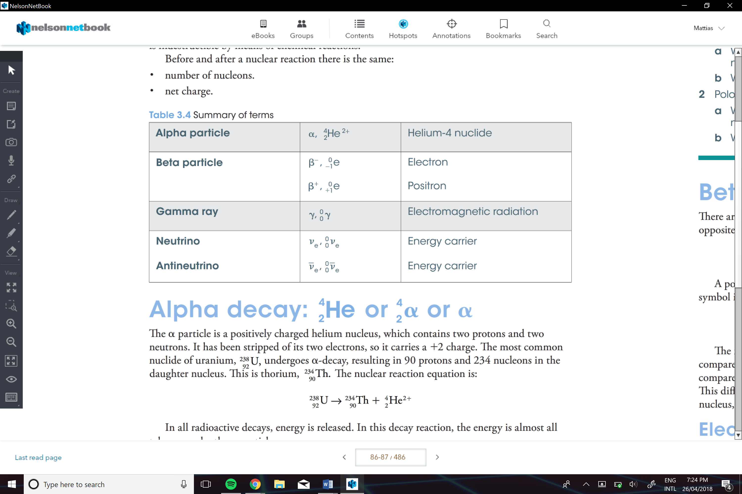

**Alpha Decay:**

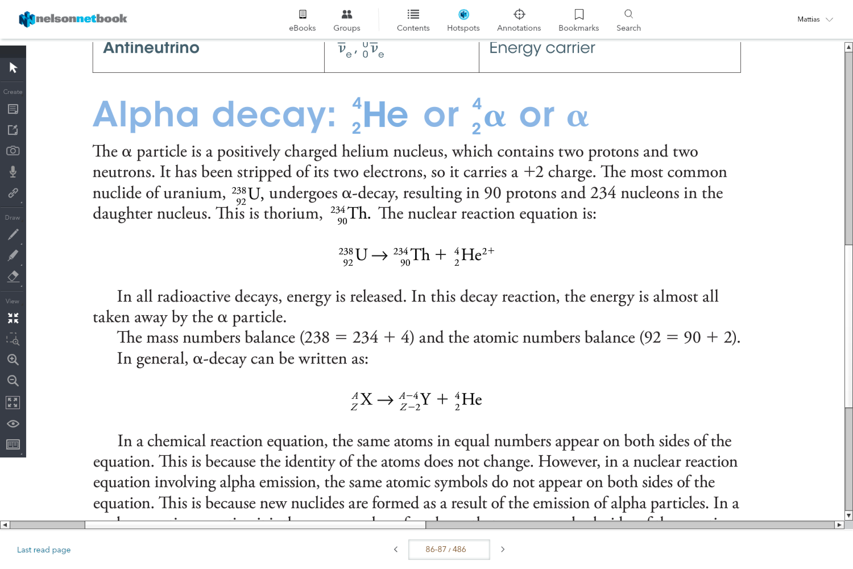Is when an alpha particle is released

e.g.

. 

**Beta Decay:**

There are two types electron emission and positron emission

Electron Emission

Is when an electron is ejected form the nucleus

* A neutron is capable of changing a proton to an electron

** an anti-neutrino is also released

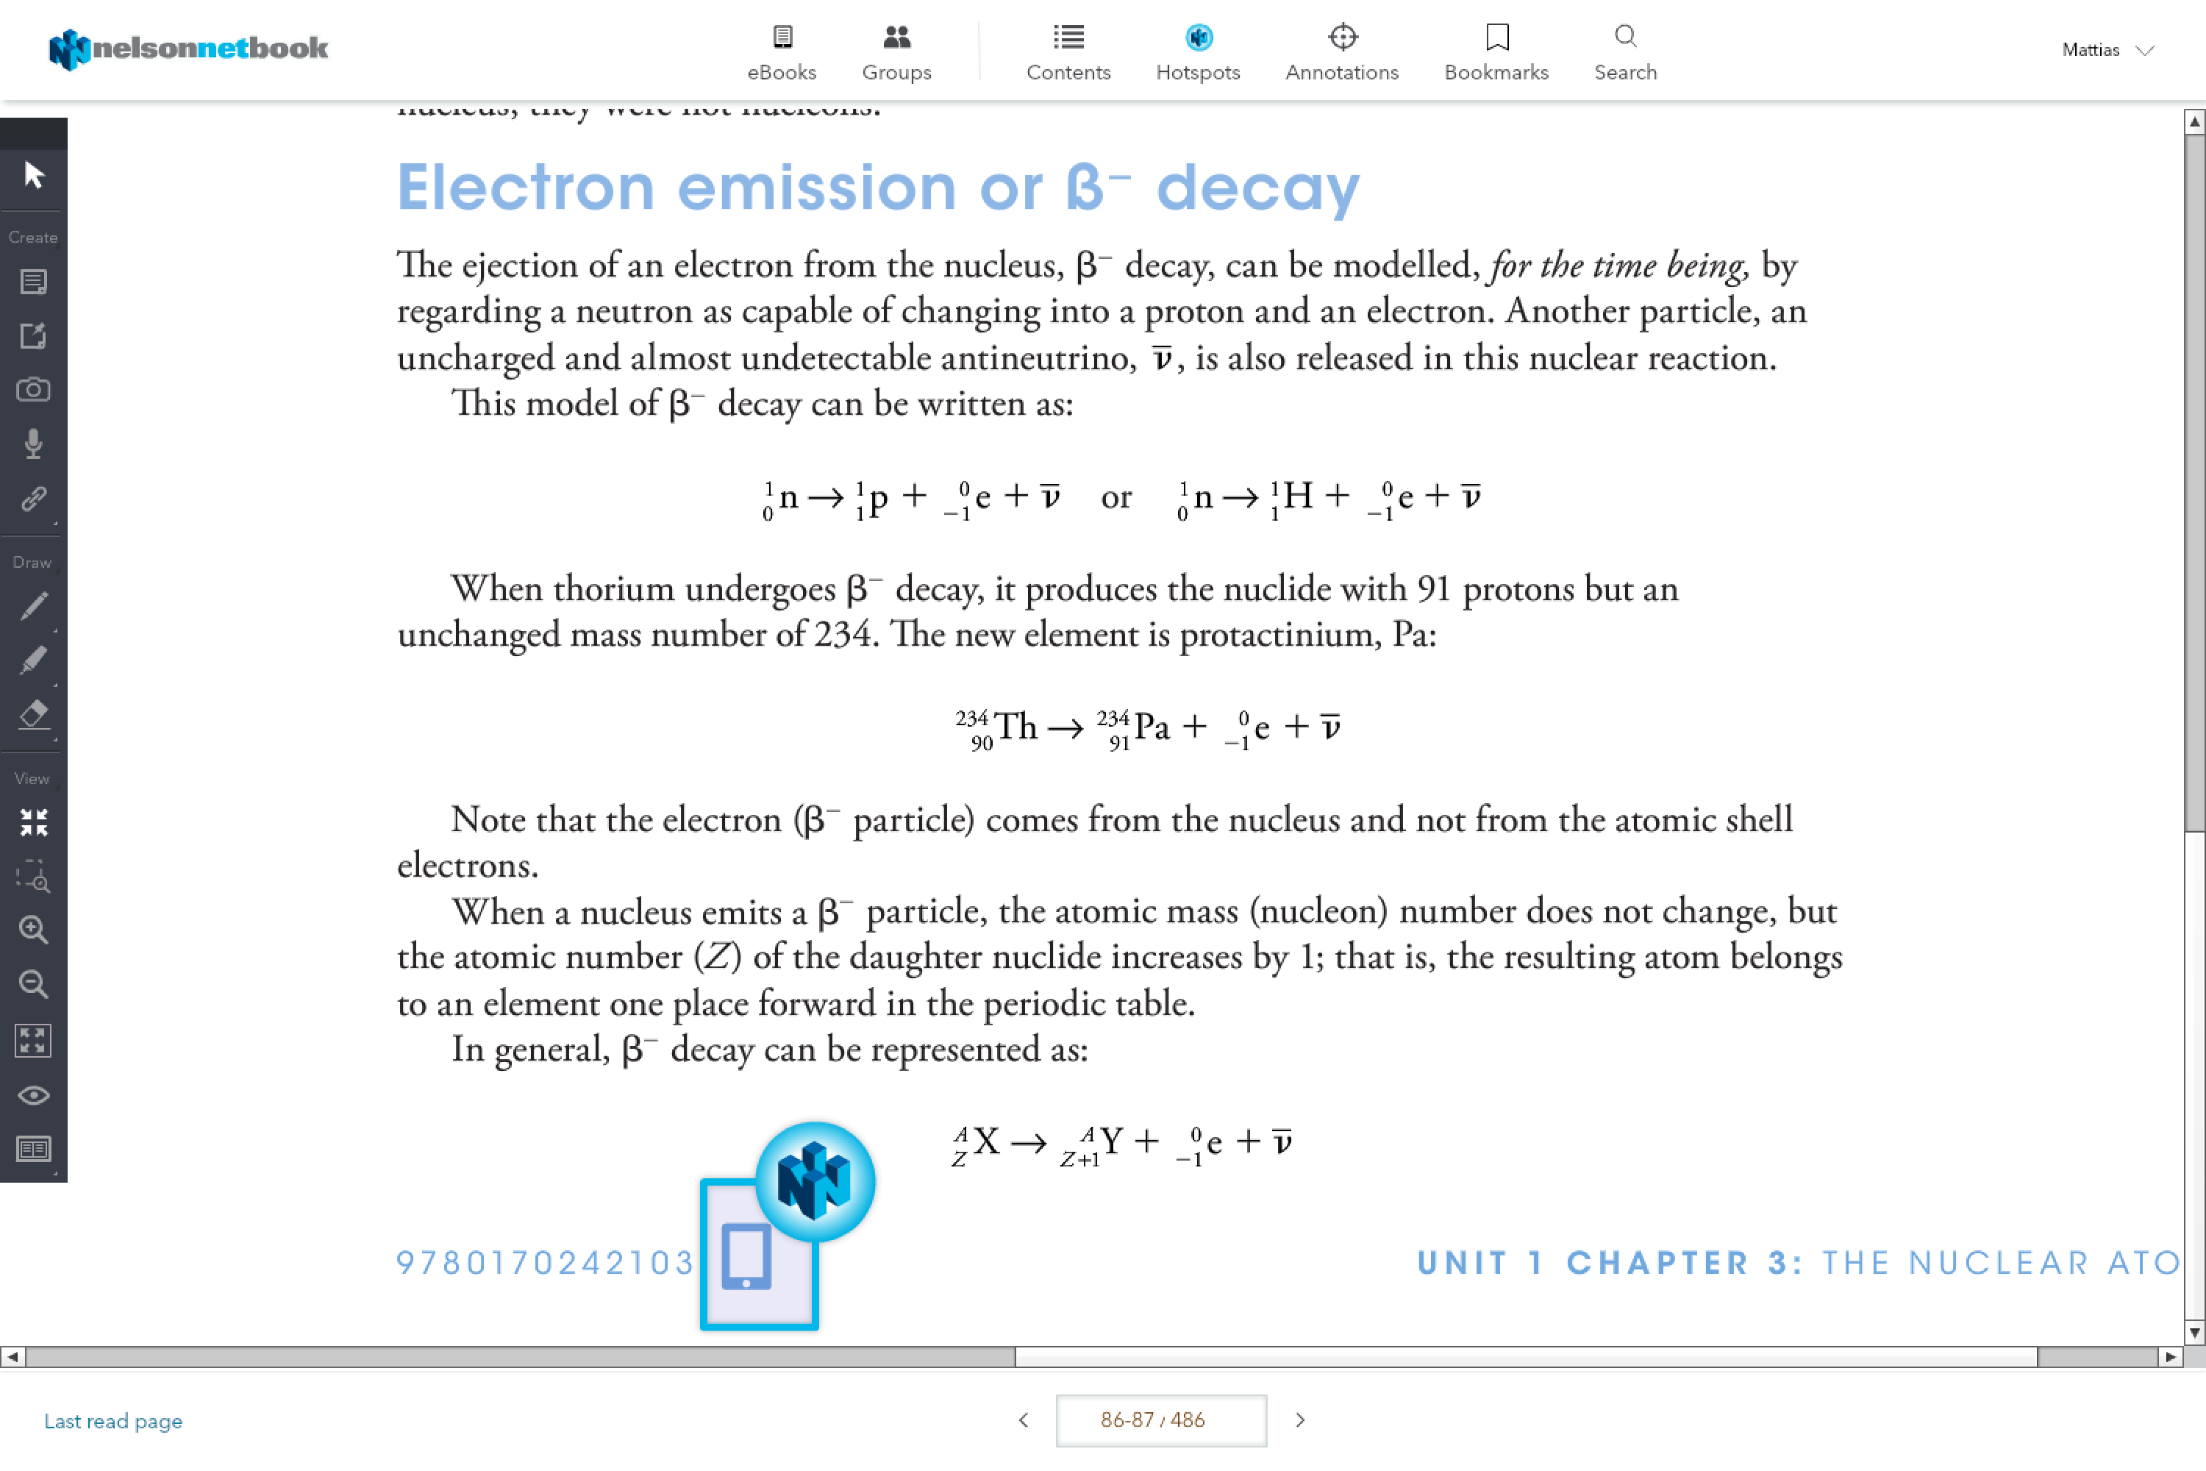

e.g.



Positron Emission or B+ Emission

The ejection of a positron from the nucleus

-by regarding a proton is capable of changing into a neutron and a positron

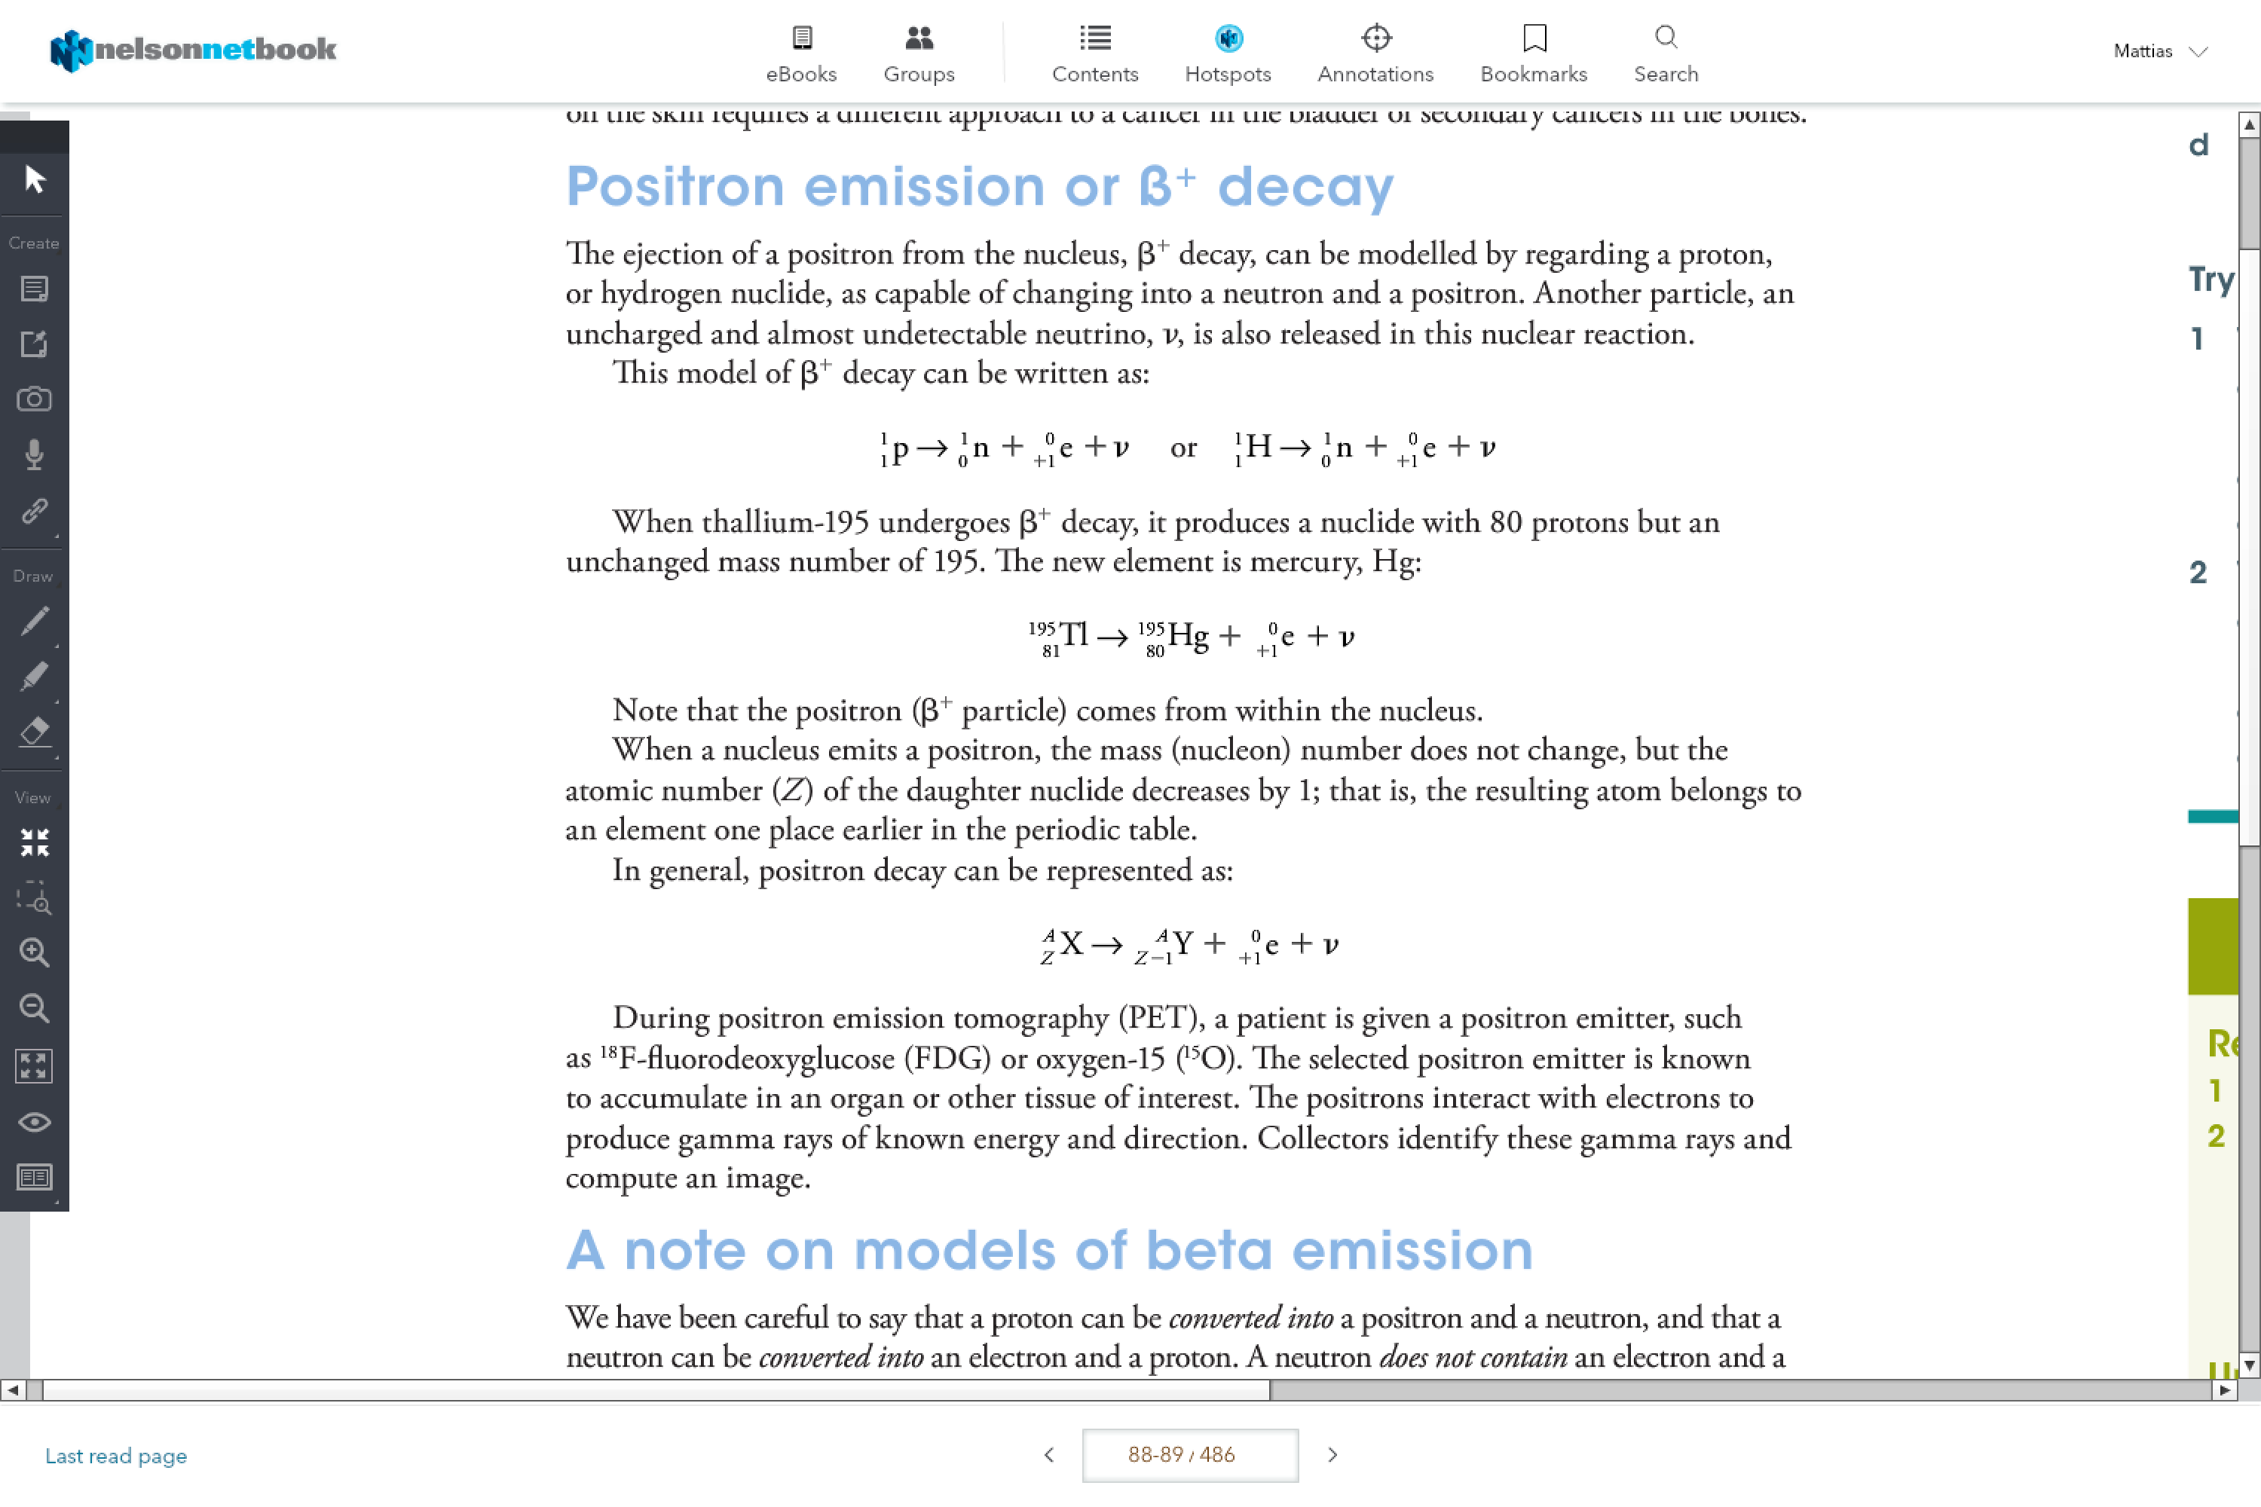

e.g.

**Ionising Power:**

Ability to ionise materials: inversely proportional to penetrating power

Alpha>Beta>Gamma

Alpha

Attract the electrons from the atoms

Beta-

Is repelled by the electrons, which then causes it to bounce between the atoms. This continuous bouncing causes some electrons to be ejected.

Beta+

Interact with the atoms.

Gamma*:*

Gives the electron energy so it can break free

**Penetrating Power:**

Ability of ionising radiation to move into or through materials

Gamma> Beta> Alpha

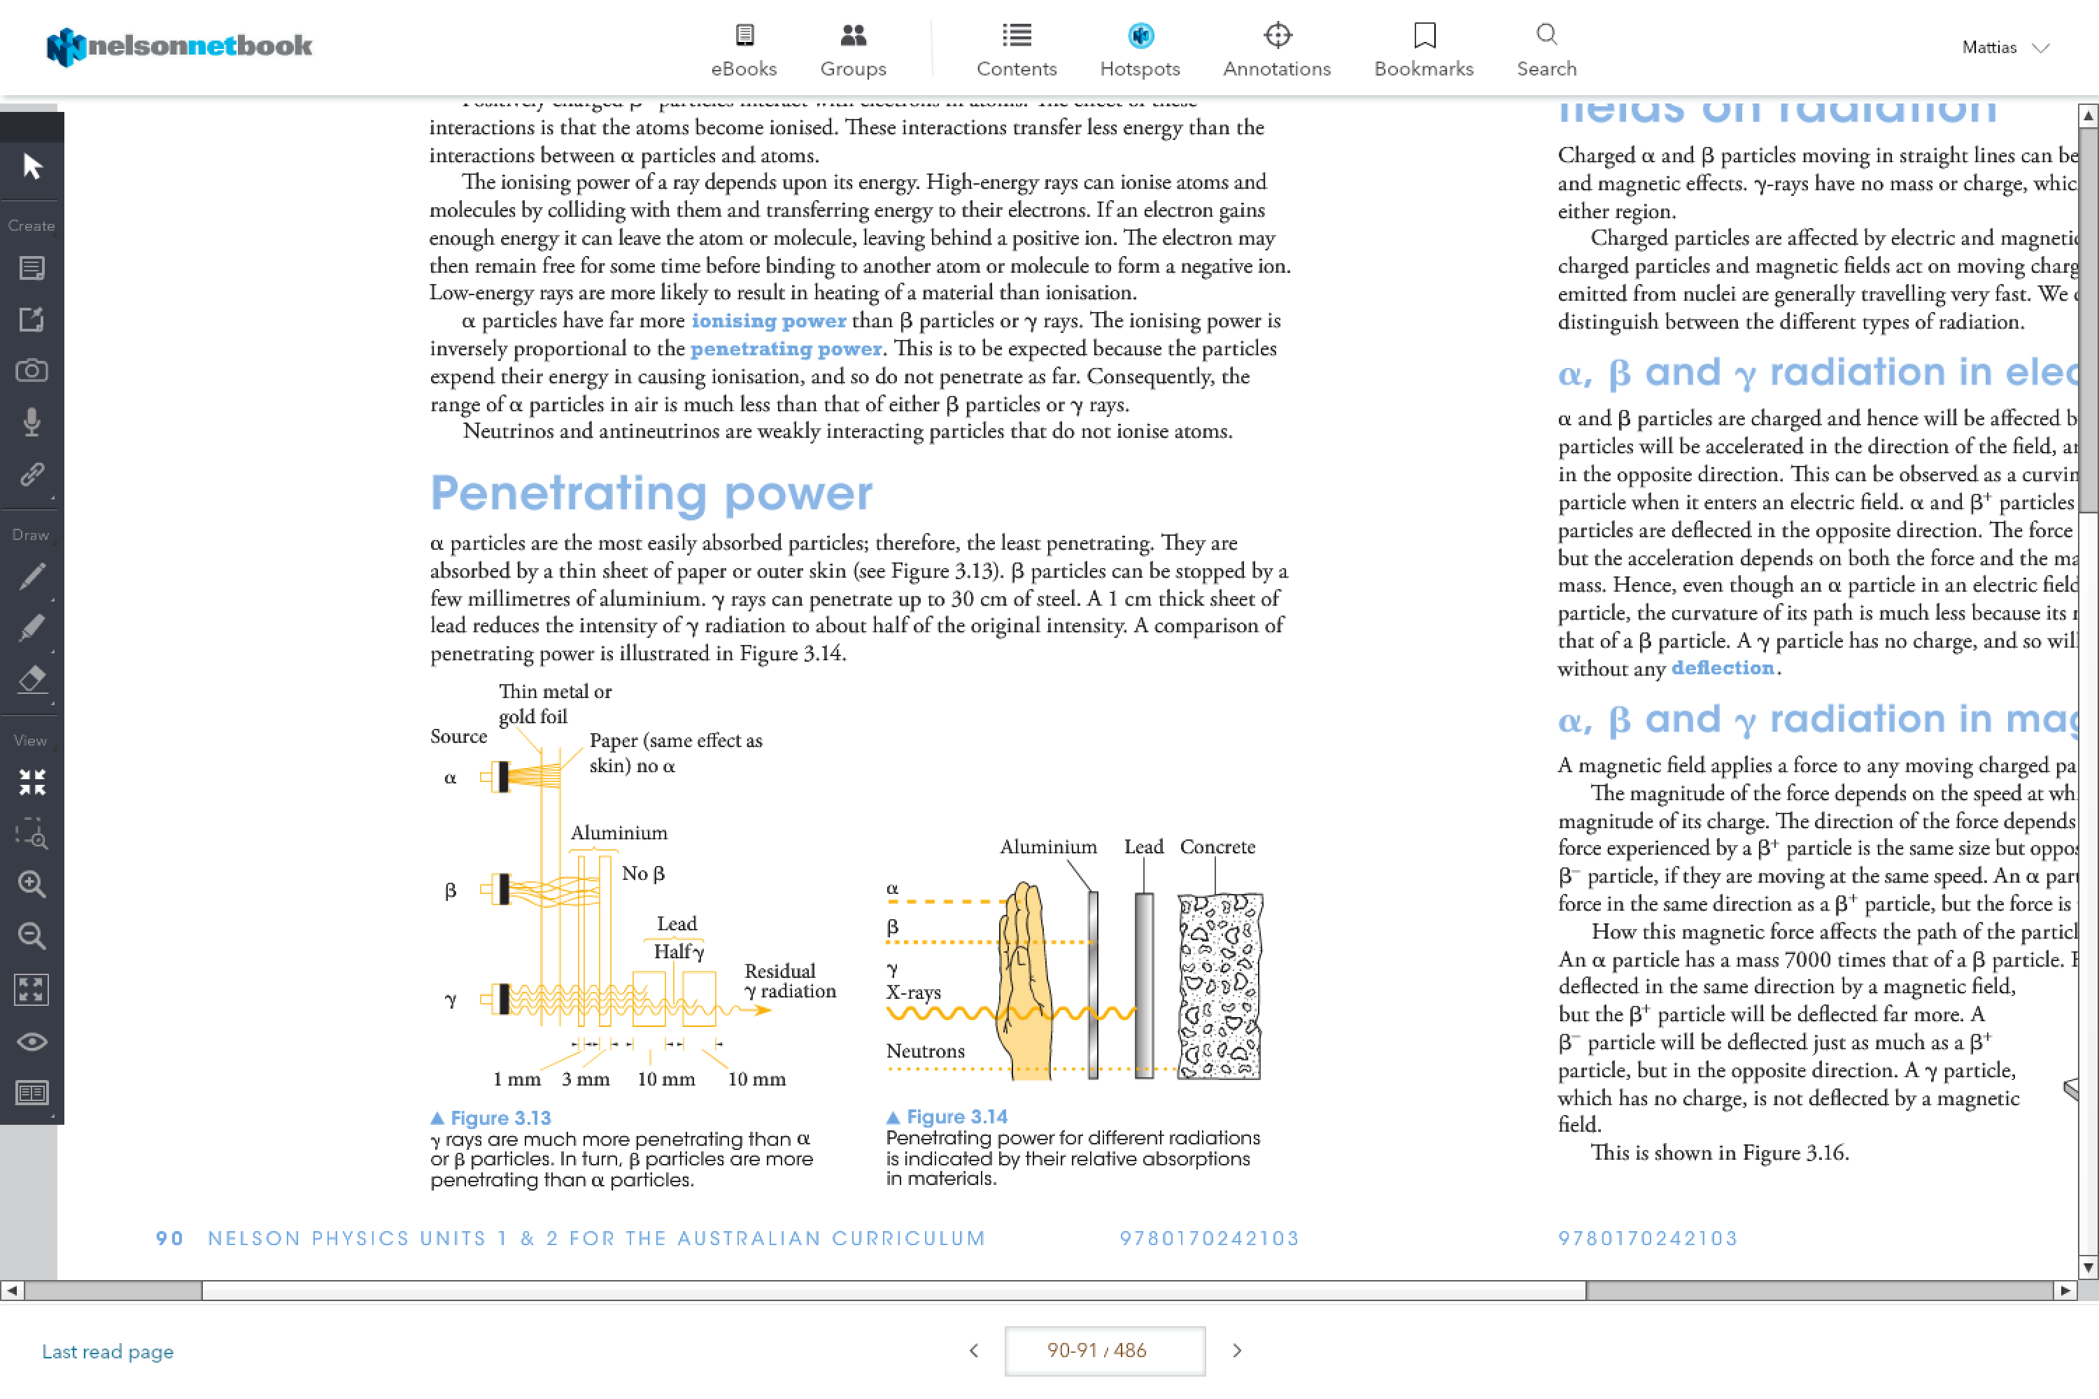

In summary

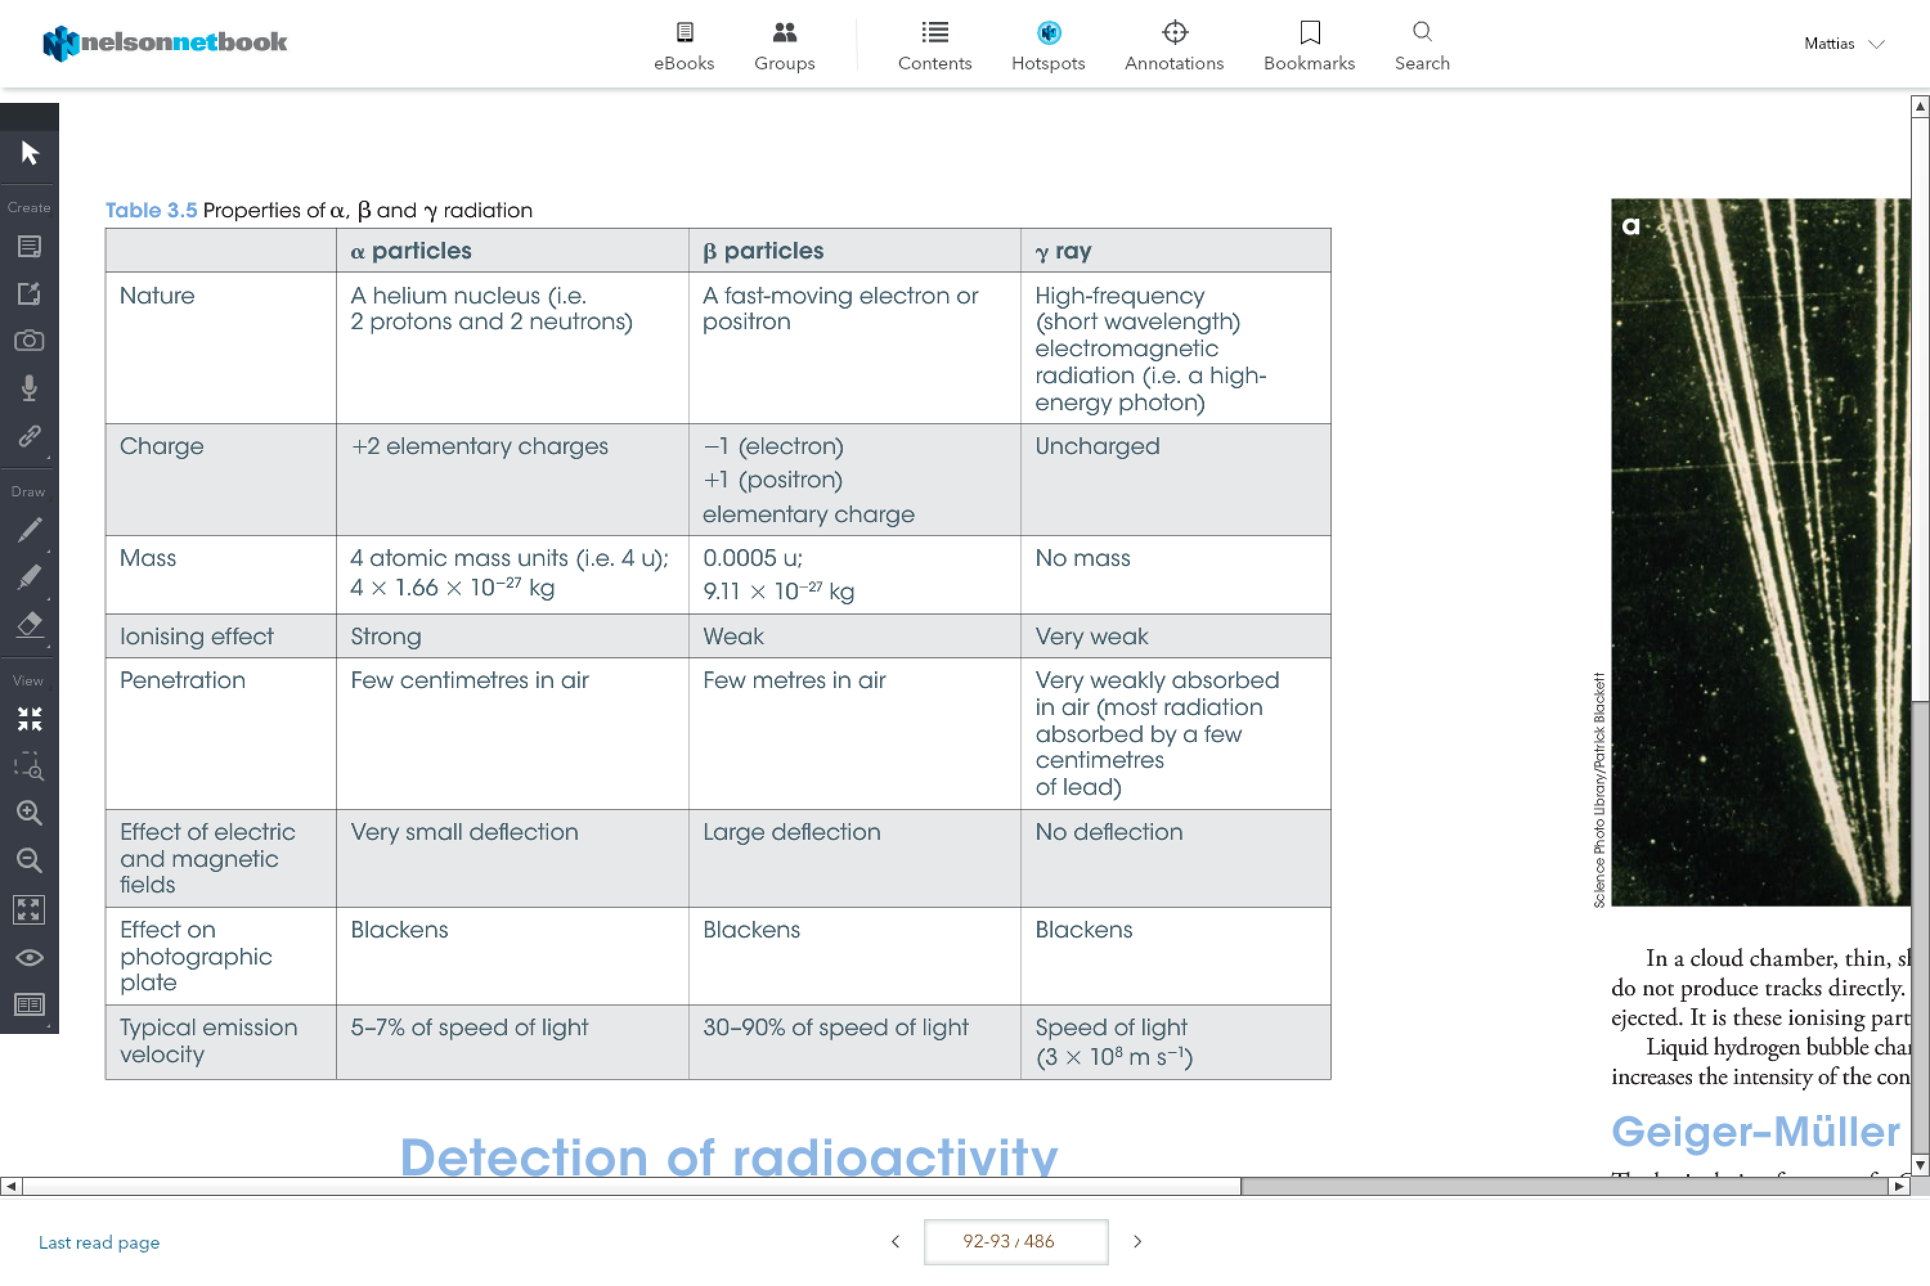

Geiger-Muller Tube

Detects radioactivity

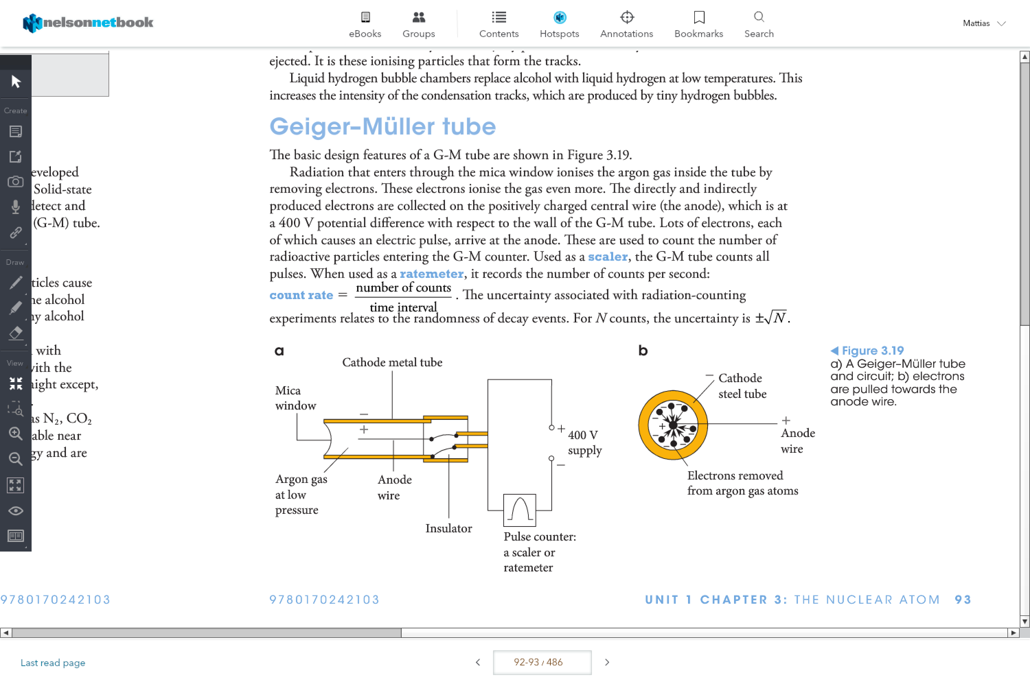

**Half lives and decay series:**

Half life is:

1. The time it takes for half of the radiation to decay
2. The radioactivity to half

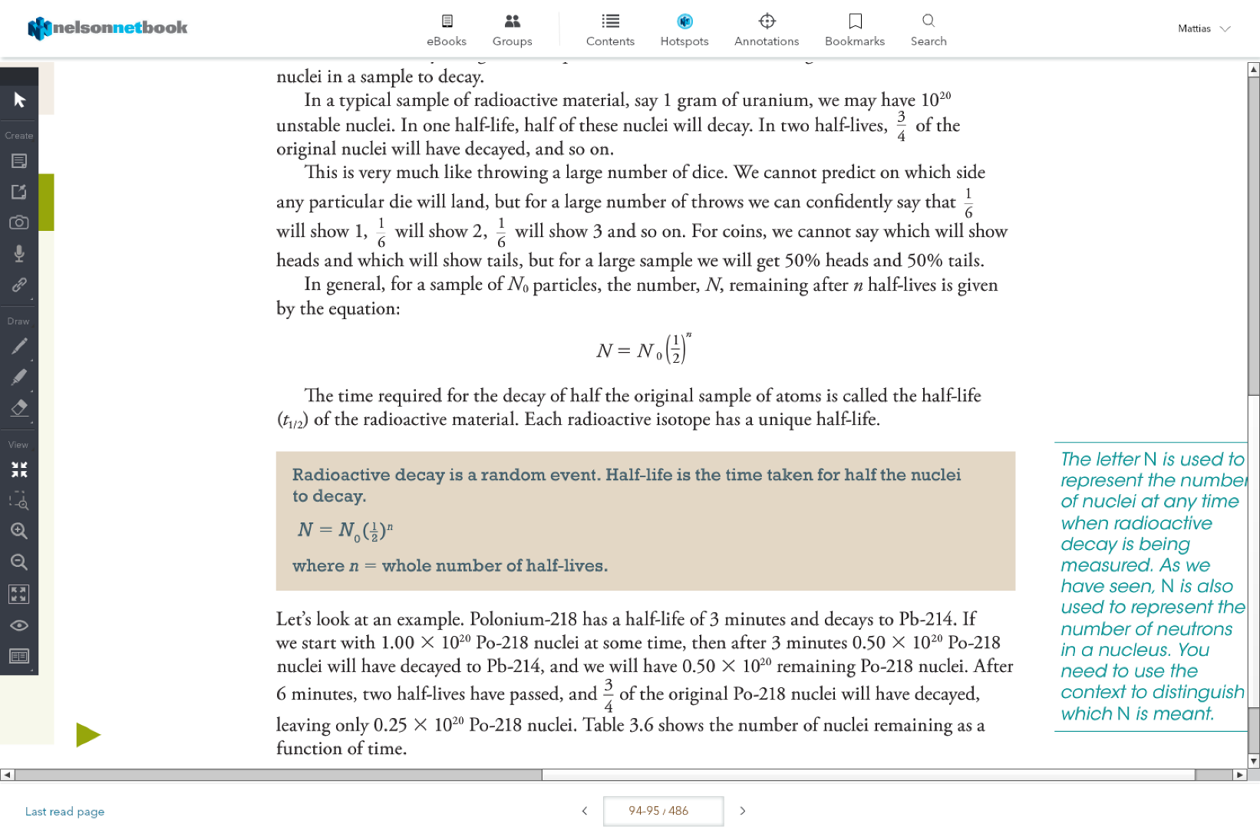

Decay series:

Cascade of decays from a radioactive nuclide until a stable nuclide is reached

e.g.

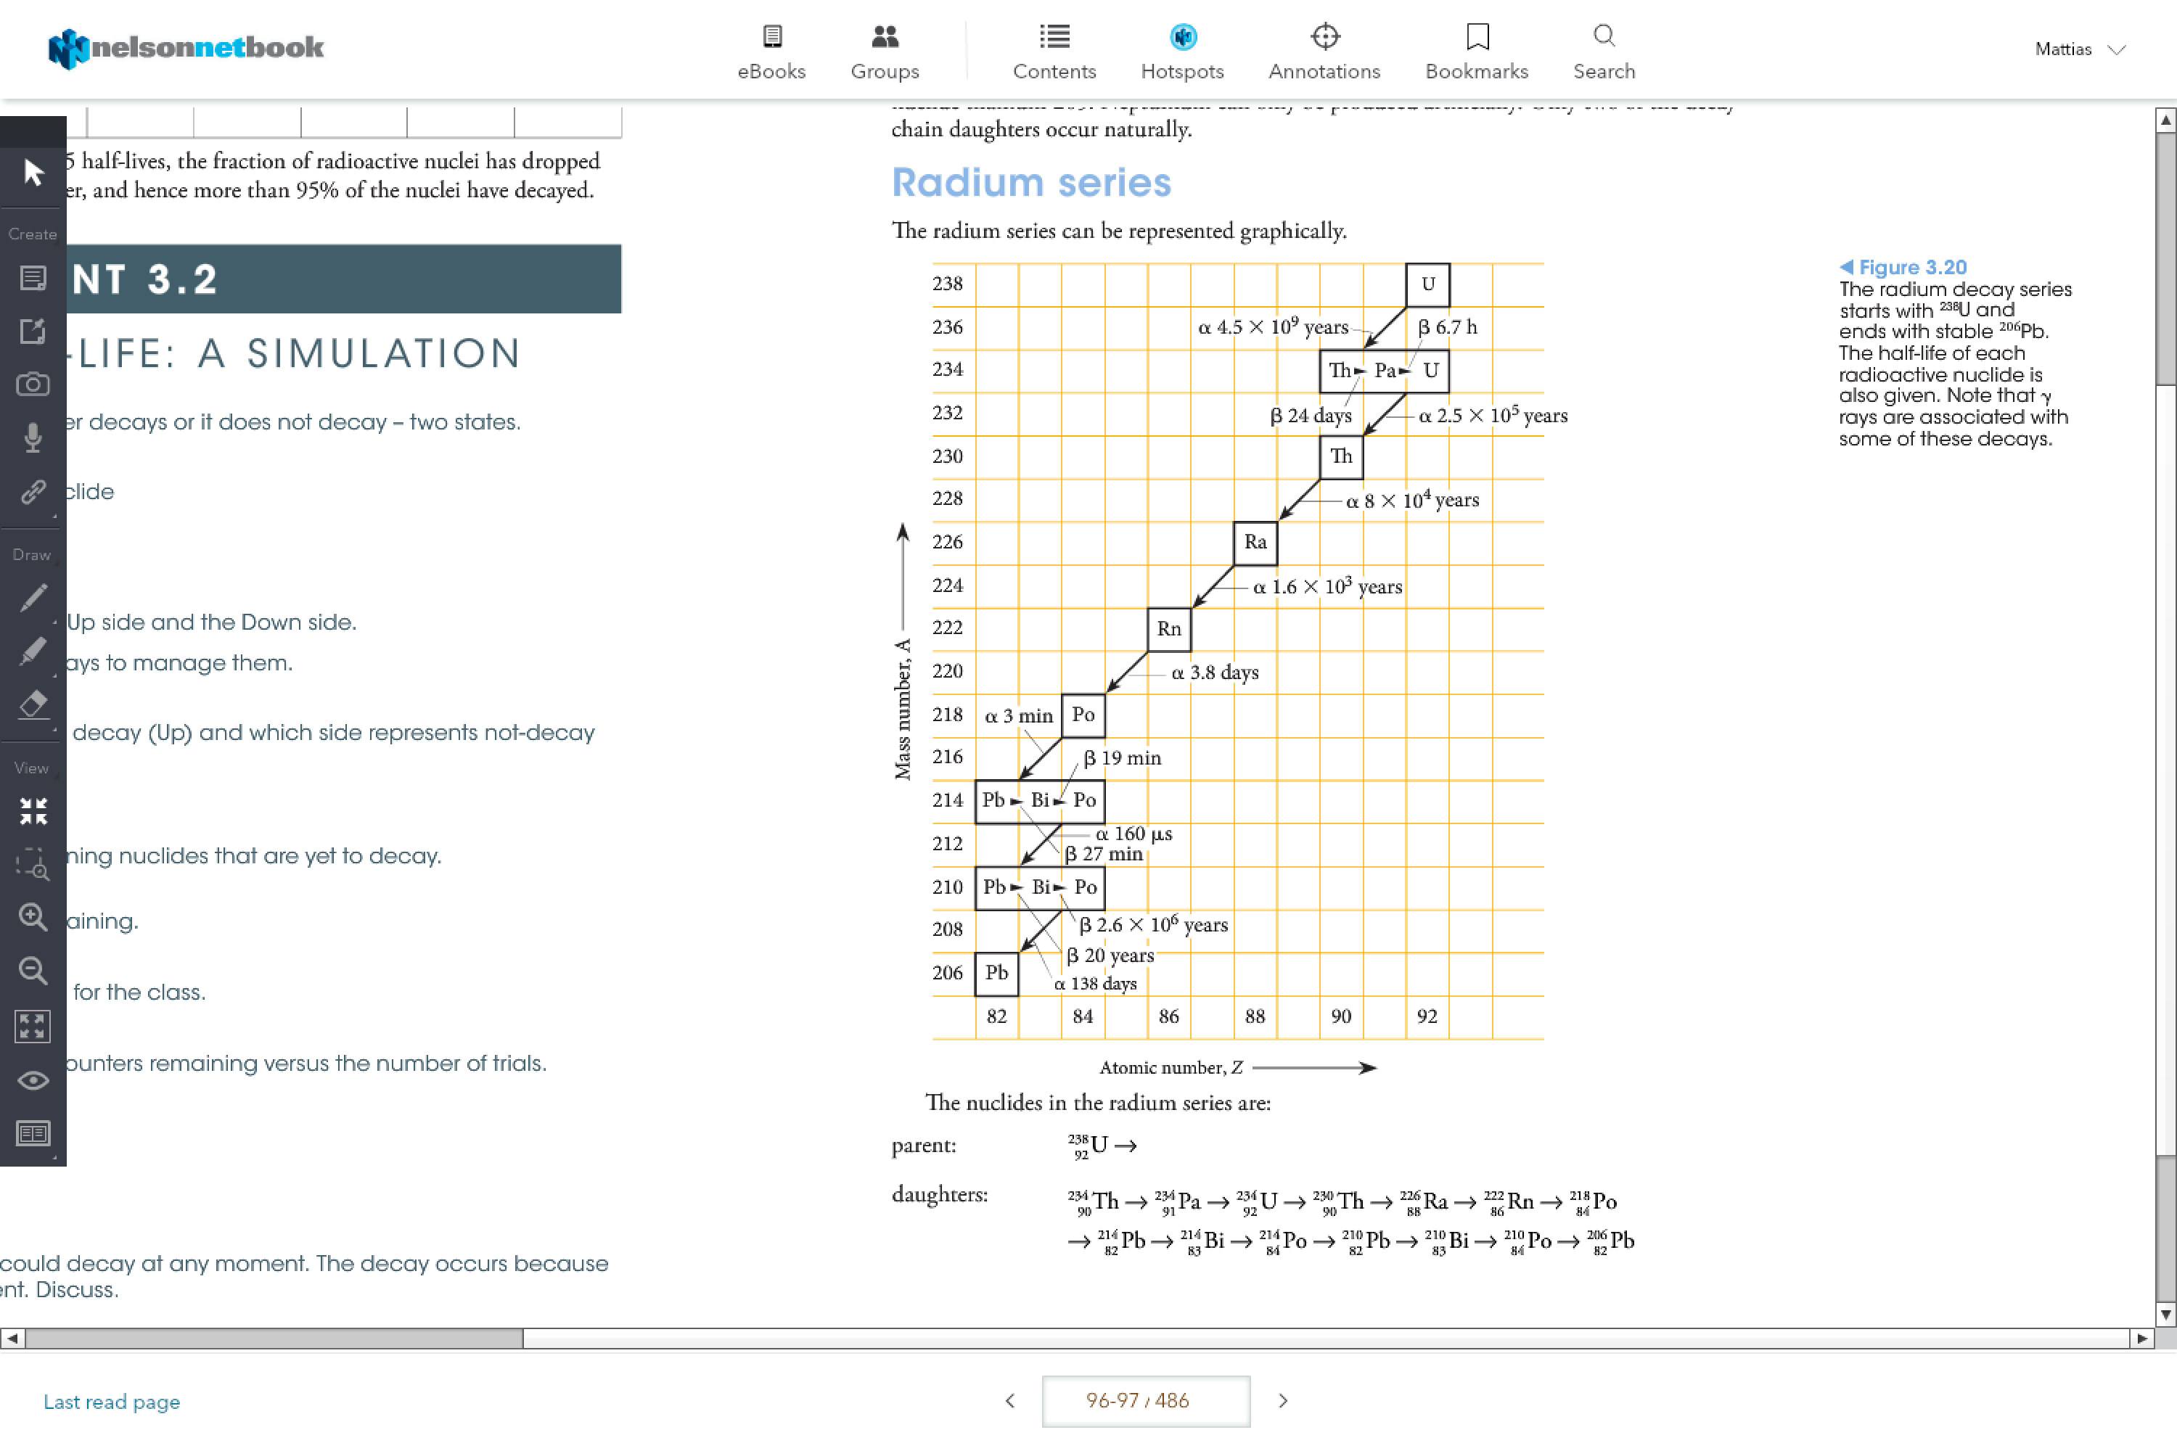

Transuranic Elements:

Elements beyond uranium; artificially produced with more than 92 protons

**Energy from the Nucleus:**

Four Fundamental Forces:

1. Strong nuclear force
2. Weak nuclear force
3. Electromagnetic force
4. Gravity

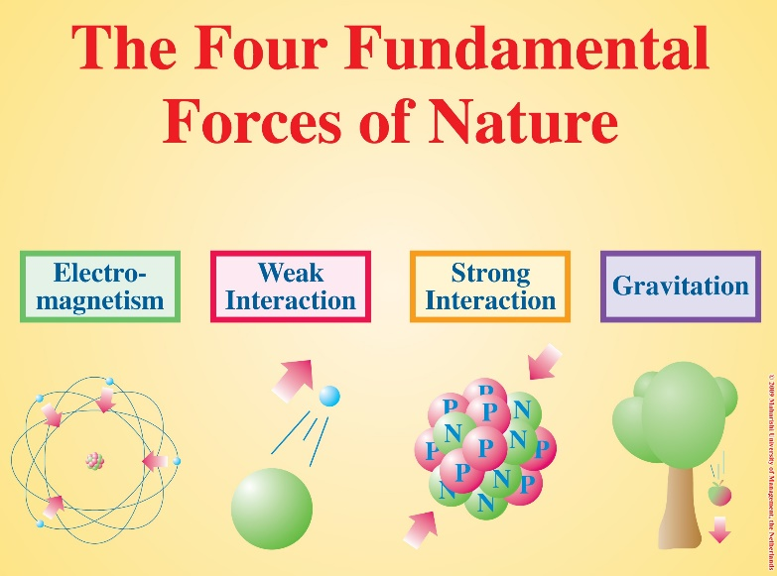

Stability:

A nucleus is stable when the strong nuclear force and the electrostatic force are equal

**Energy Stored in, and Released from, Nuclei**

Nuclear Binding Energy:

The total energy needed to hold a nucleus together.

Mass defect:

The difference between the sum of the individual masses and the mass of the nucleus into which they are combined is

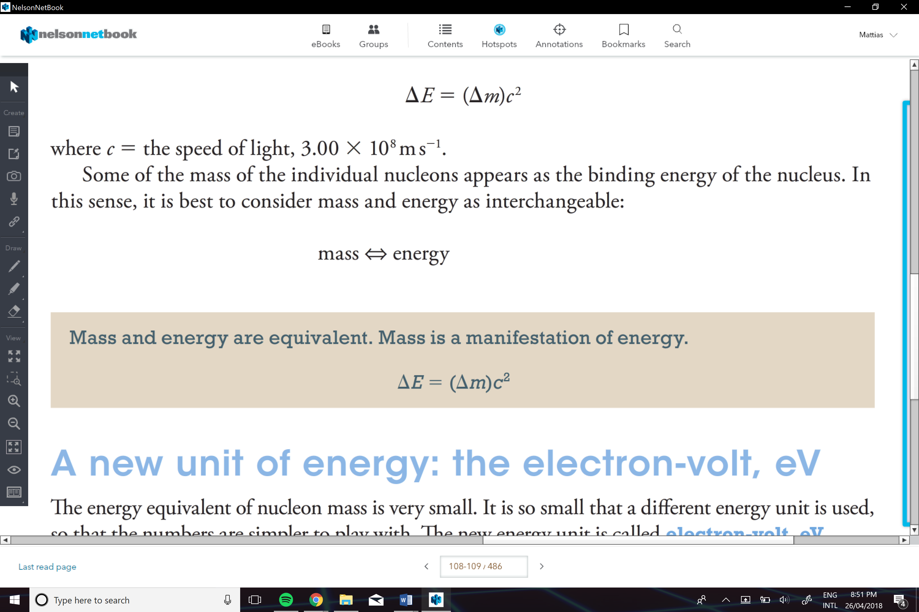

The more binging energy => the nuclide is more stable

Iron-56 is the most stable of the nuclides

**Fusion:**

Is the coming together of two nuclides to form a new nucleus with a greater atomic number

**Fission:**

Is the splitting of a heavy nucleus (Z>56) into fragments with lower atomic numbers.

-the nuclei, called fission fragments, are more stable than the original nuclide because of their lower binding energy

Binding energy per nucleon governs stability. The higher the binding energy per nucleon the more stable the nuclide.

* Fusion is favoured for light nuclides (Z<56)
* Fission if favoured for heavy nuclides (Z>56)

More energy is released per nucleon in nuclear fusion than in nuclear fission because a greater percentage of the mass is transformed into energy

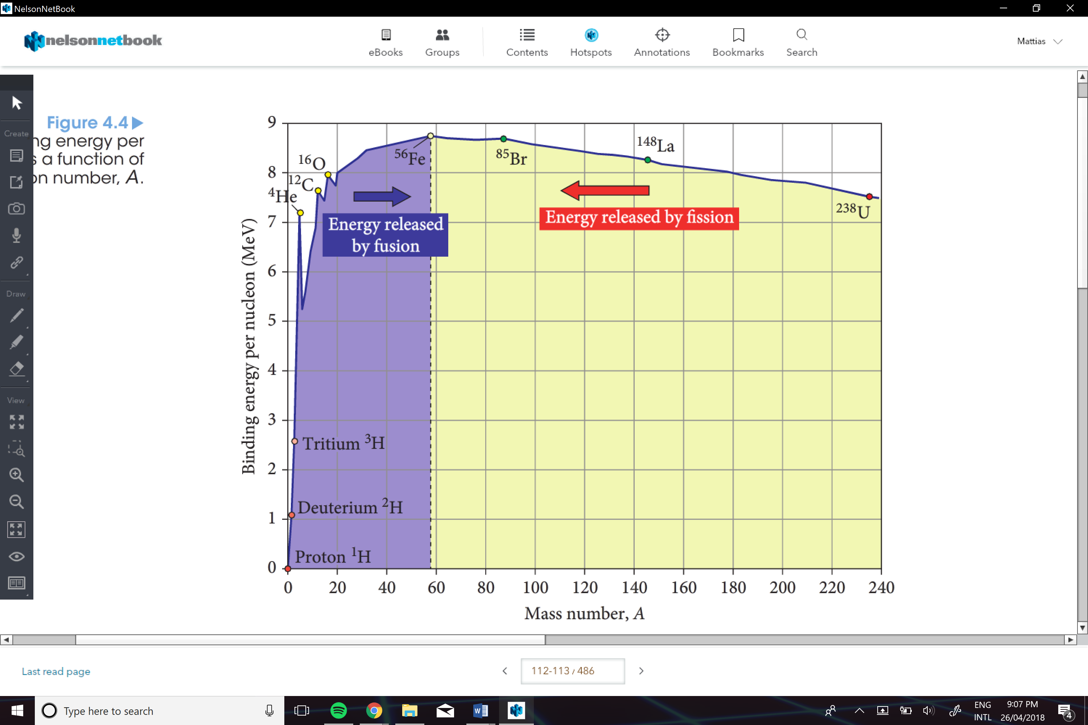

**Nuclear Energy: Fission**

Is the process by which a nucleus splits into two fragments.

In general, the fragments are rarely the same size.

Nuclear fission is triggered by the absorption of a neutron

In the process, neutrons are released and energy stored as binding energy is released

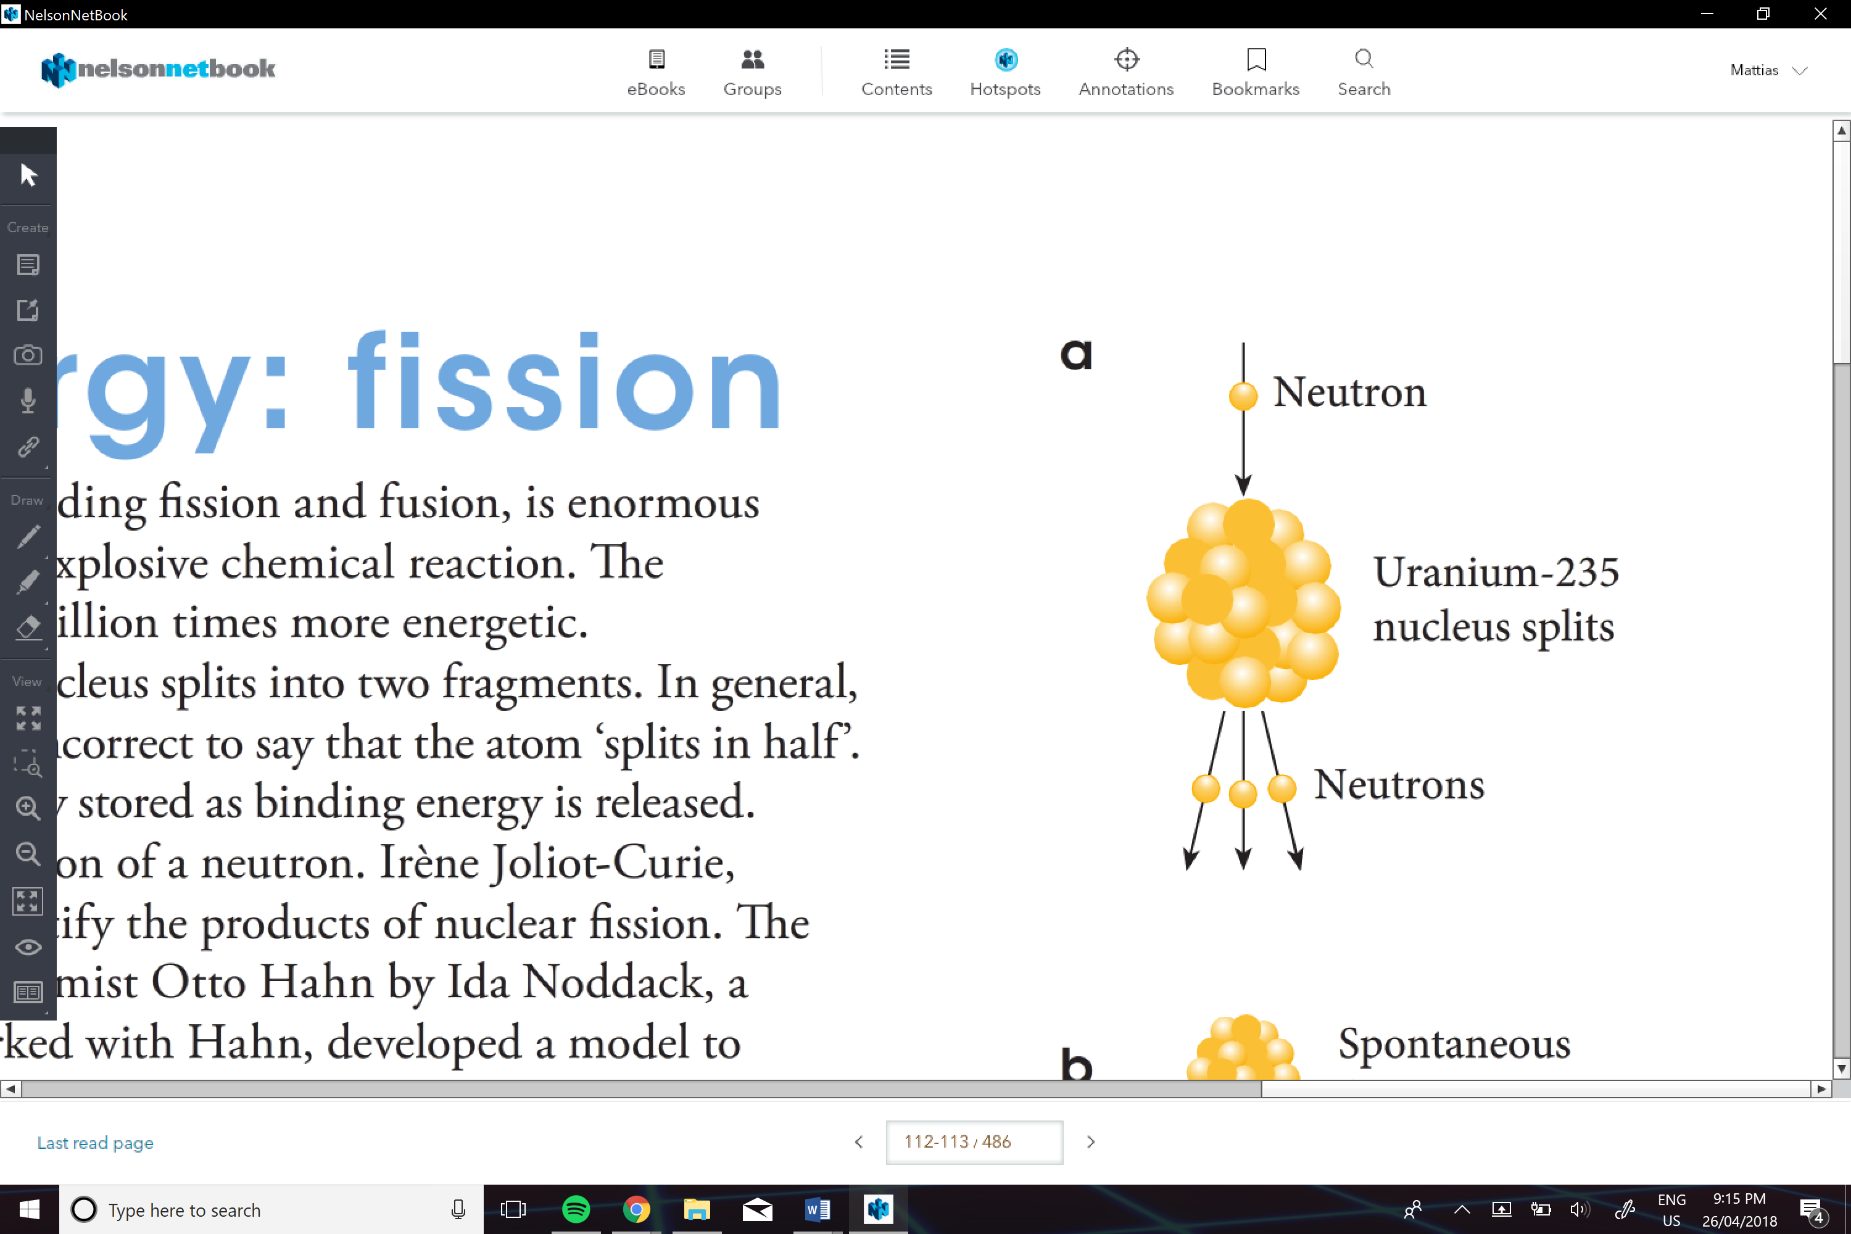

**Fission Chain Reactions:**

Occurs when more than one of the neutron released from the initial fission event cause new events to occur.

-This rapidly multiples to huge numbers of fission events. Unless this is carefully controlled, a runaway explosion will occur.

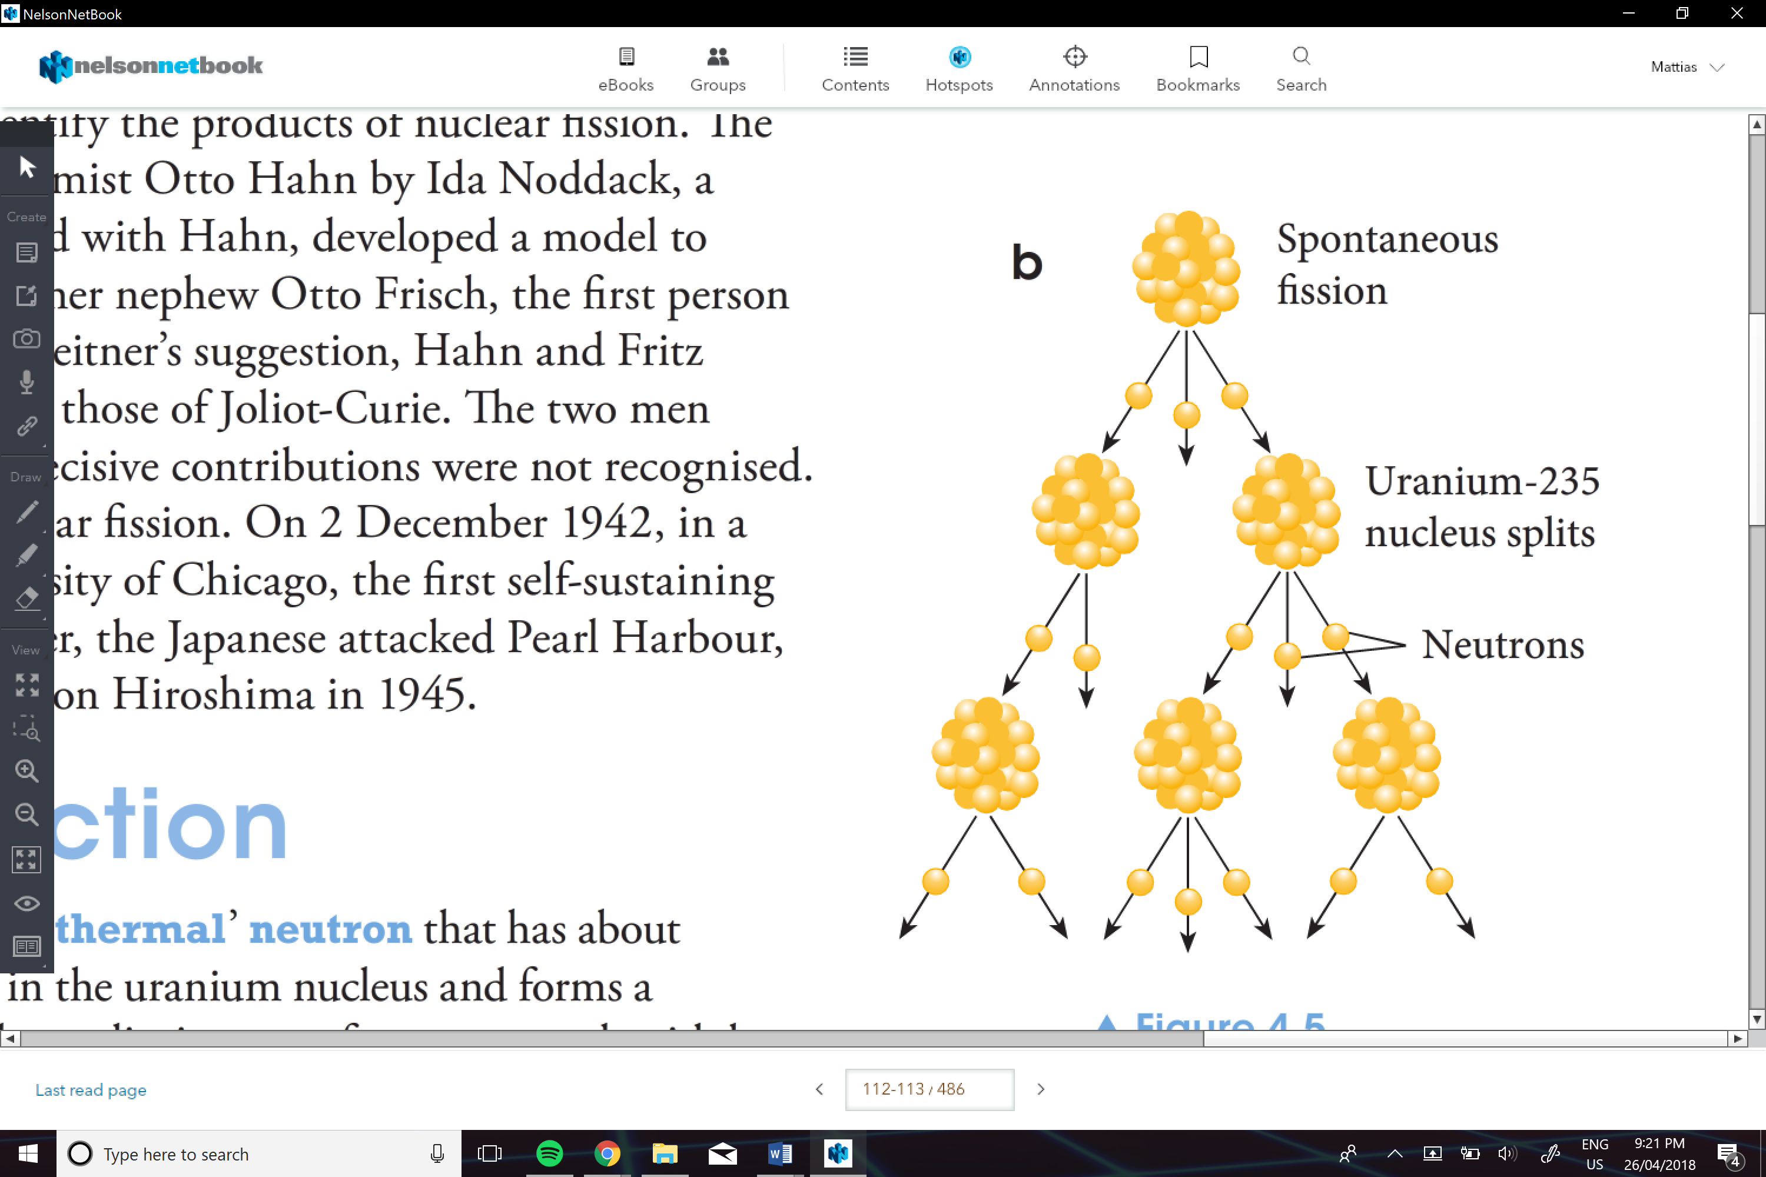

Fissile:

Nuclides that are capable of undergoing nuclear fission after absorbing a neutron

Fission Fragment/ Product:

Nucleus produced in a fission event

Neutron Poison:

Nuclei including fission products that absorb a neutron, thus making that neutron unable to cause further fission events

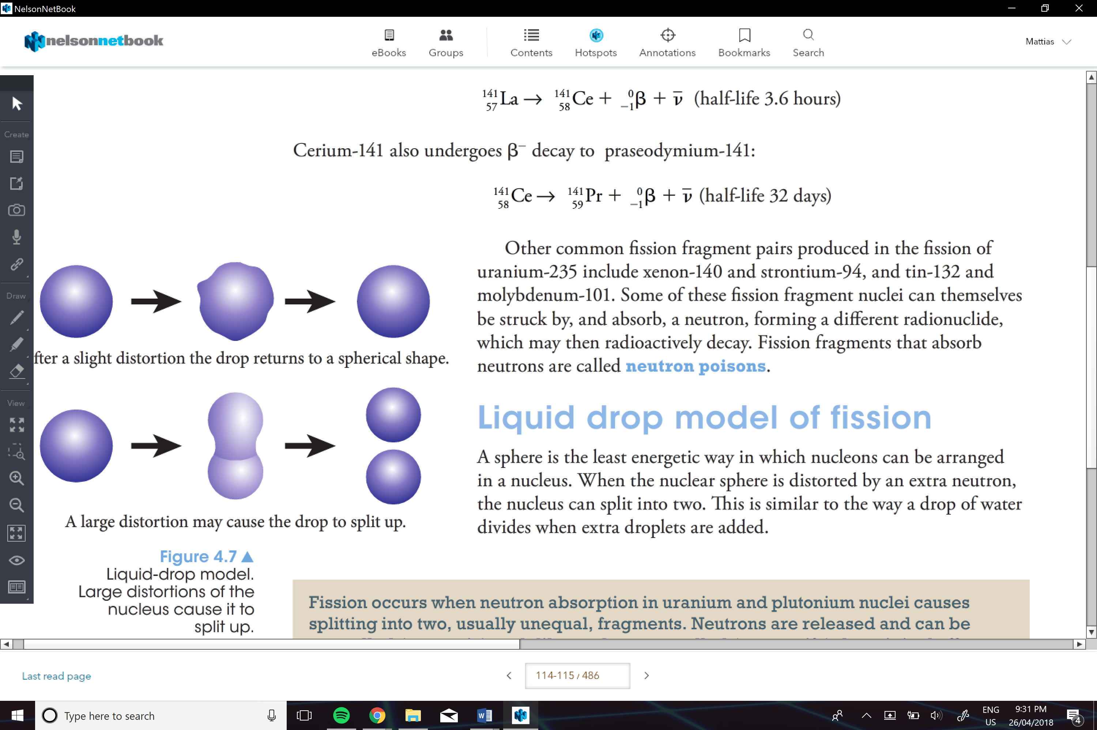

Mass defect in fission:

The mass difference is what is converted into energy

-the energy is transferred via the fission products

-the daughter nuclei carry most of this energy as kinetic energy

e.g.

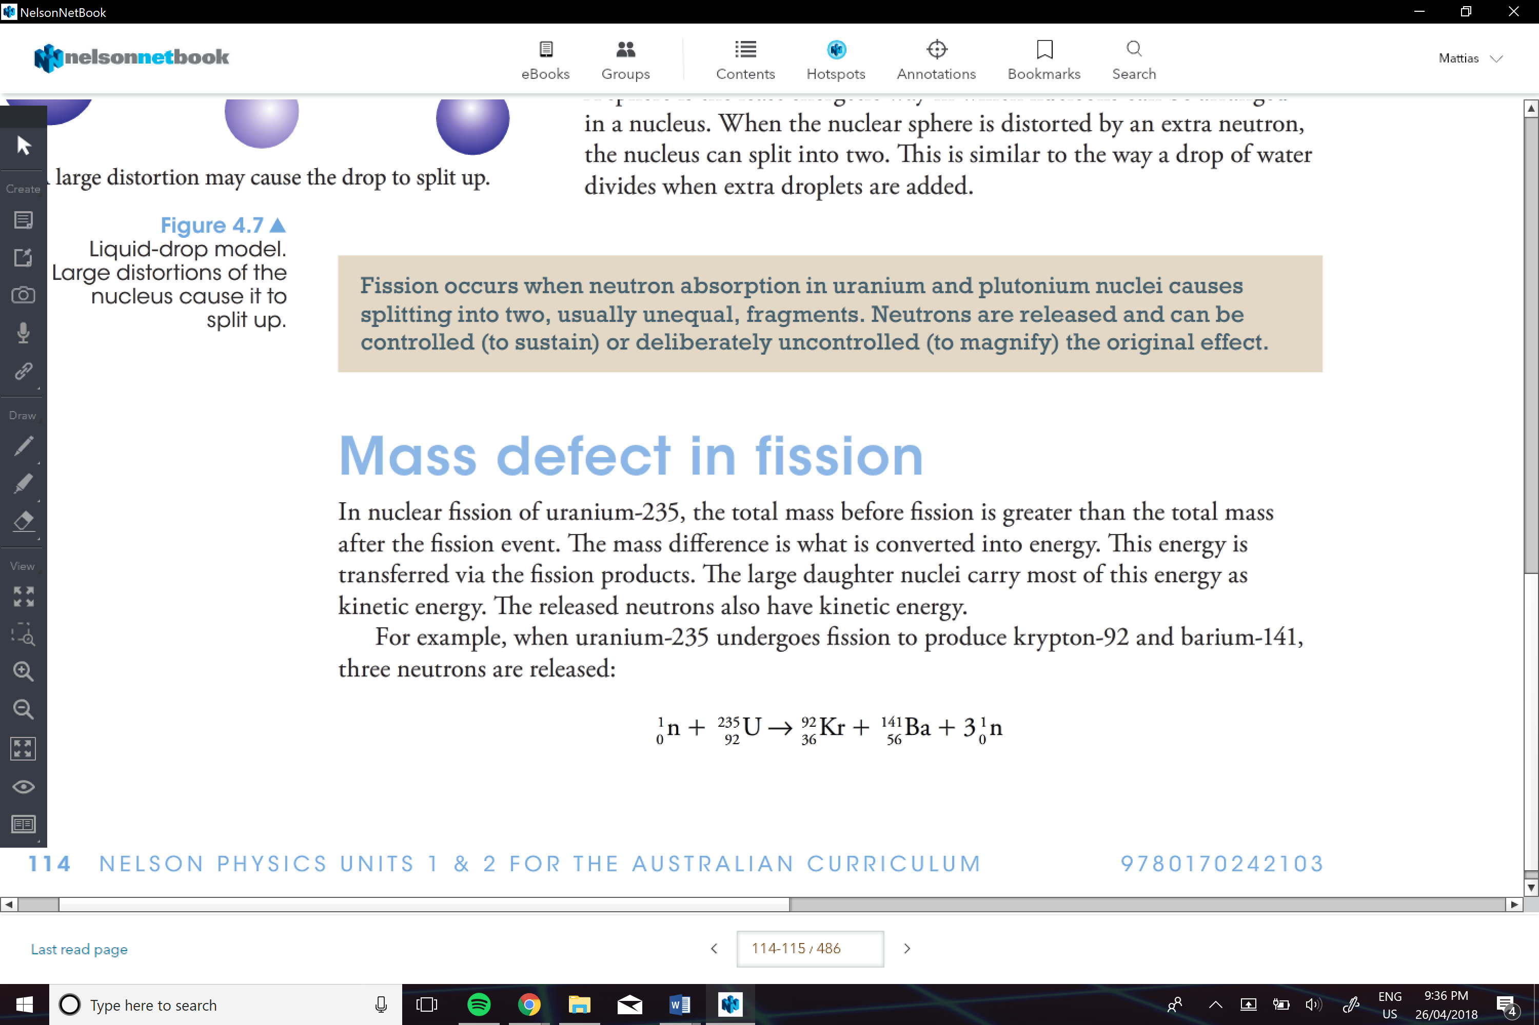

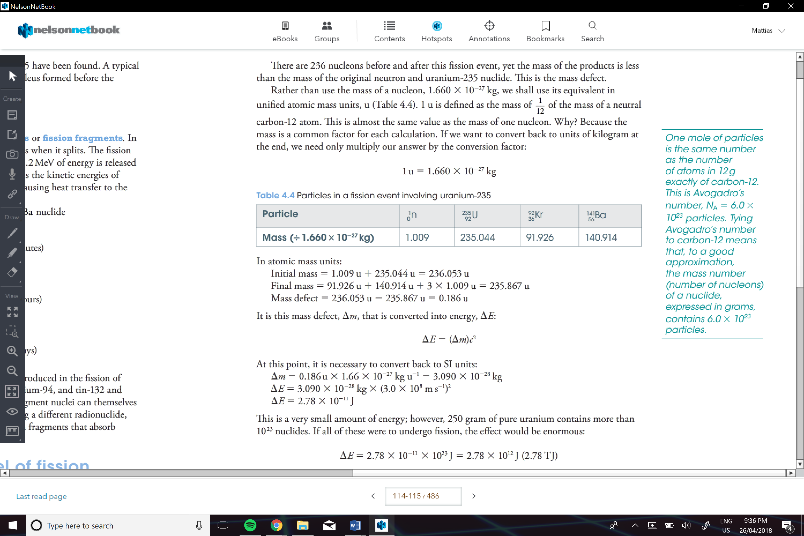

**Nuclear Reactors:**

Is a device in which controlled fission is used to produce both new substances and release energy

Controlled Chain Reaction:

A chain of nuclear reactions that are controlled to limit the rate at which reactions occur. In steady state (reaction rate held constant), an average of one neutron from each reaction goes on to cause another reaction. This is the case for a nuclear power reactor running at constant power outlet.

**Parts of a Reactor:**

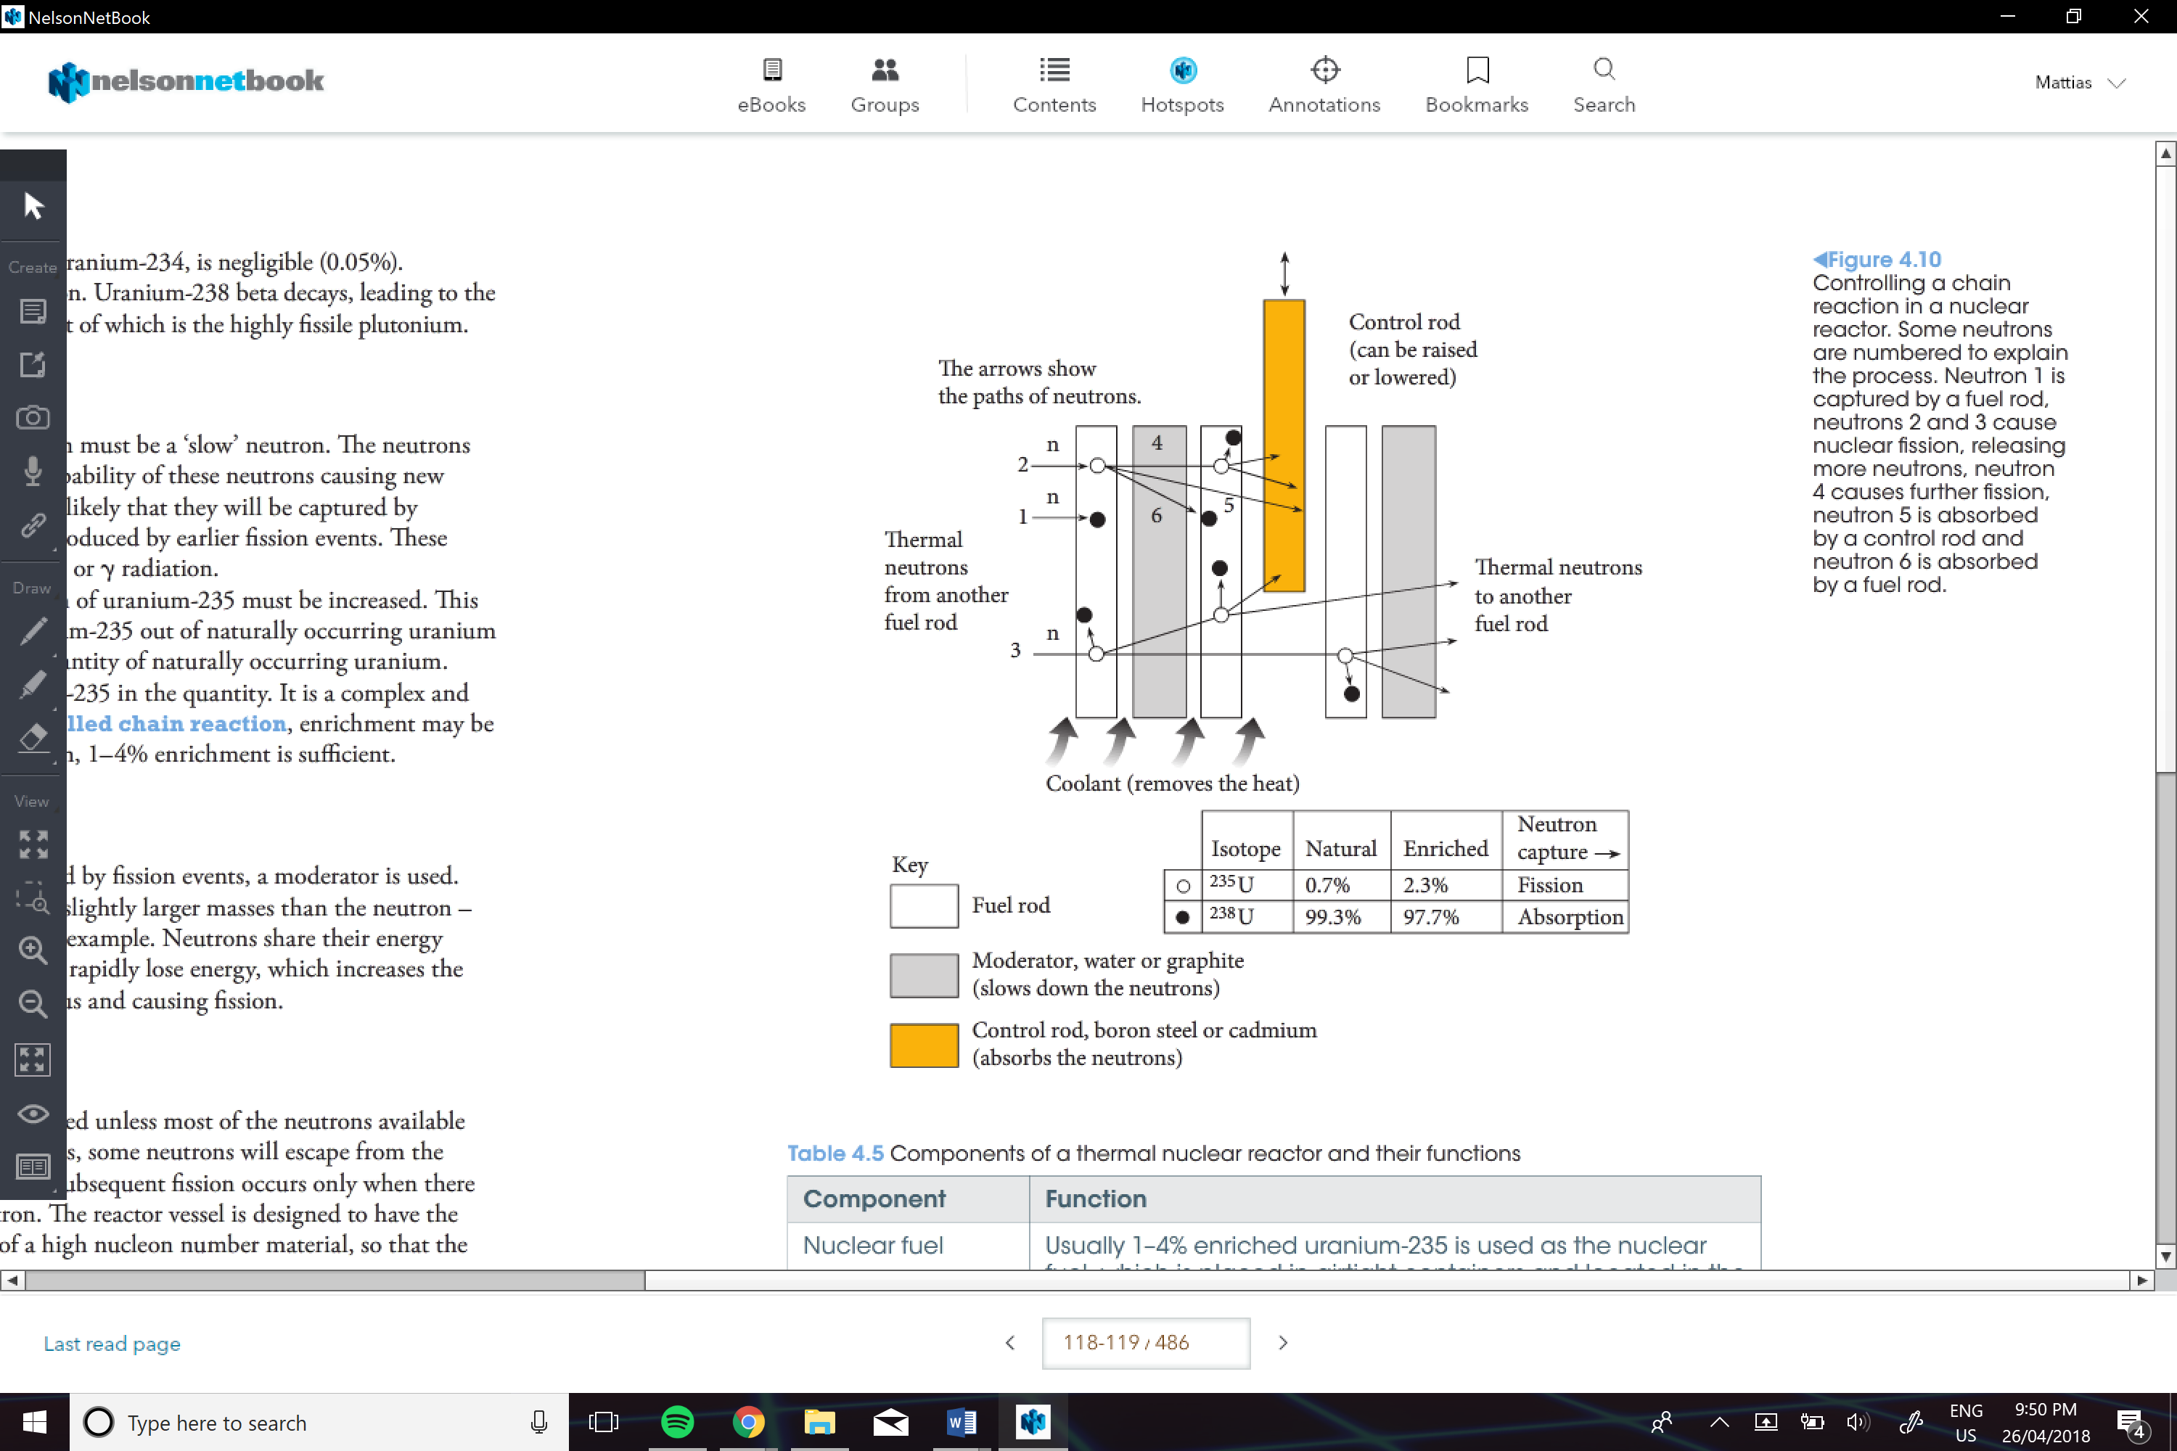

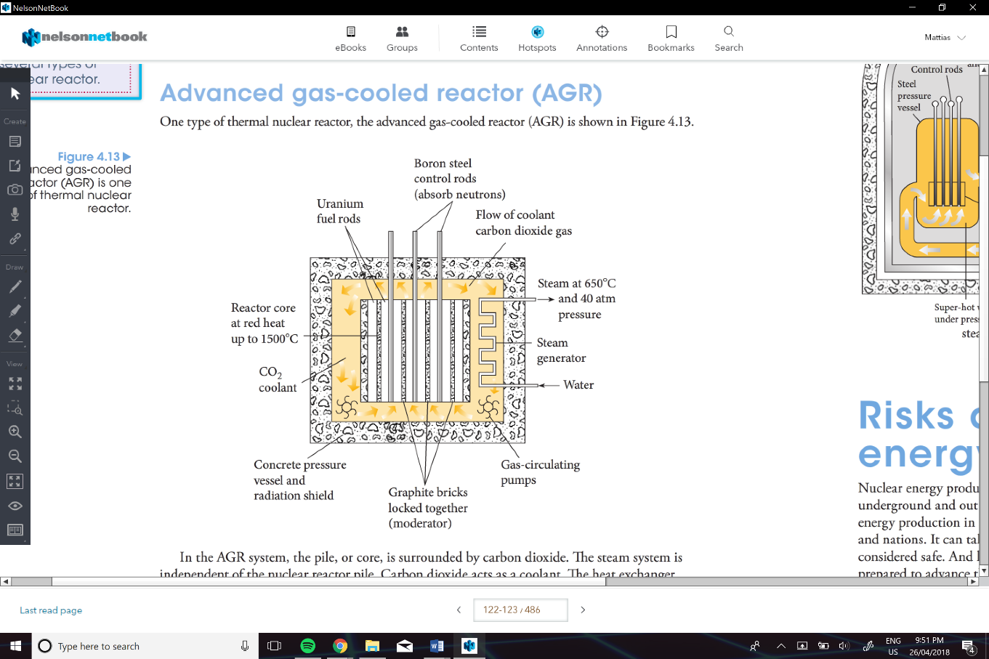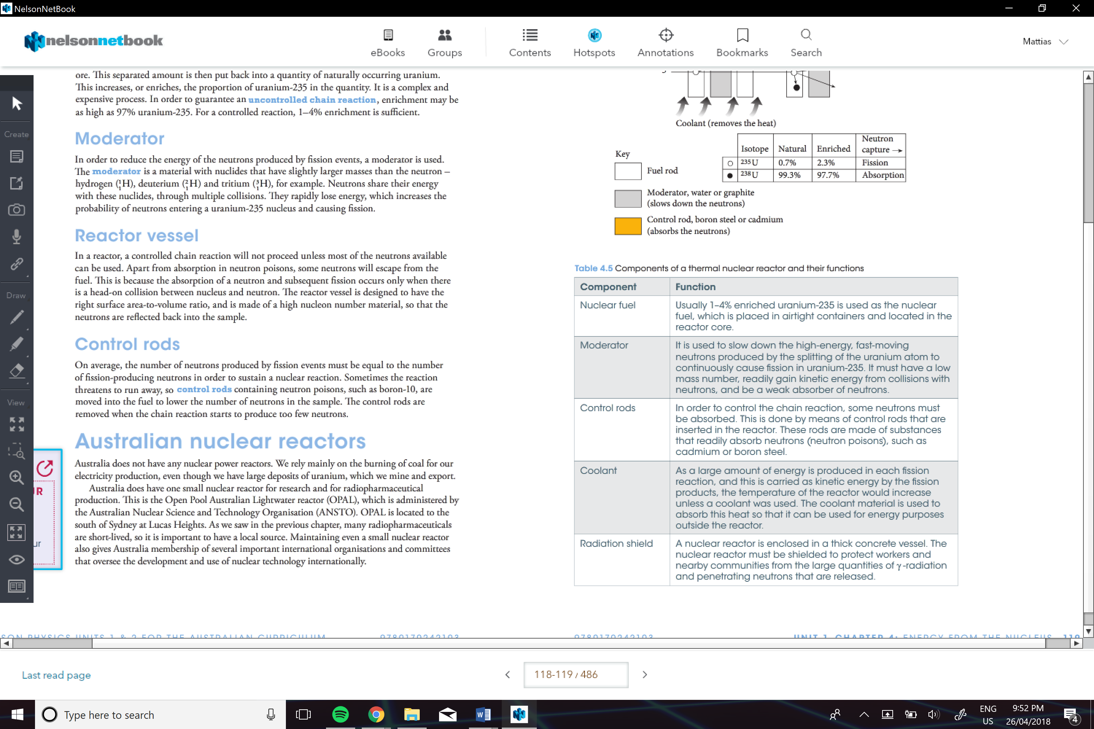

<- Is a advanced gas-cooled reactor (AGR) but u can also get a pressurised water reactor

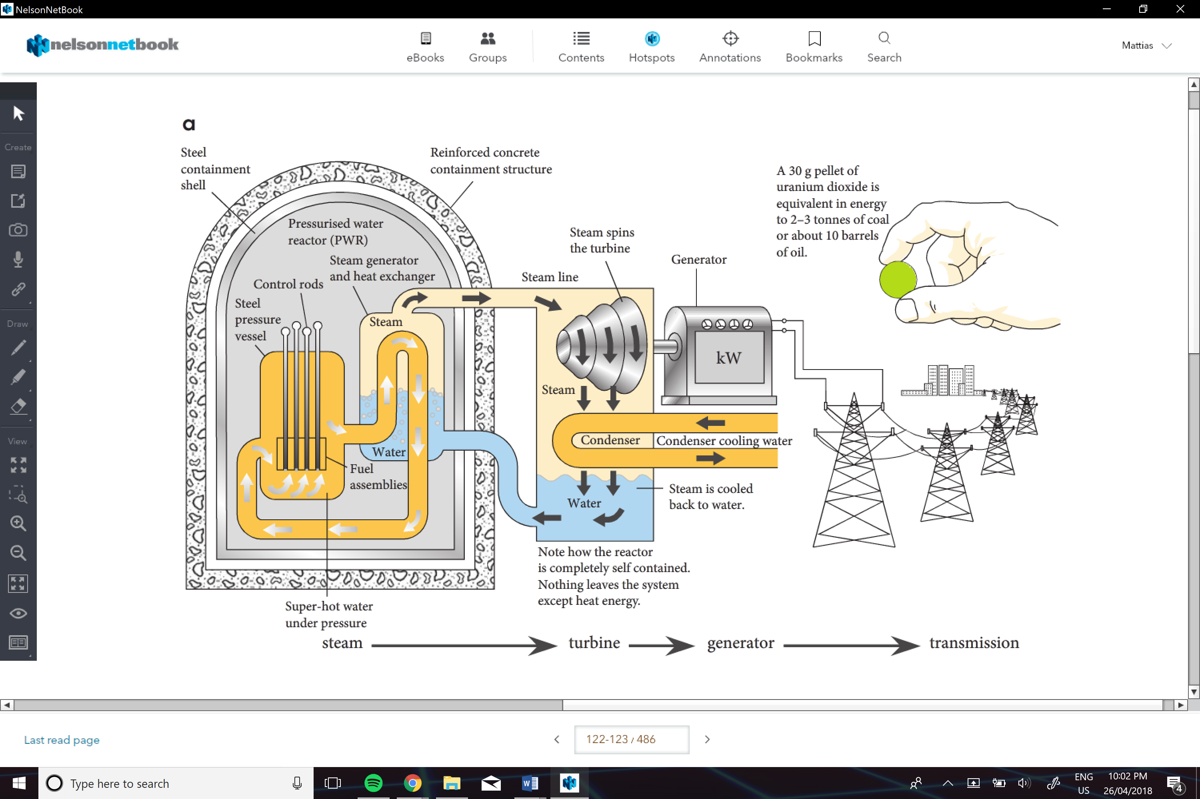

Cons:

1. Environmental Impact
2. Radioactive Waste Disposal
3. Nuclear Accidents
4. High Costs
5. Uranium is Finite
6. Hot Targets for Militants

Pros:

1. Low Pollution
2. Low Operating Cost
3. Reliable
4. More proficient than fossil fuels
5. Compact

**Fusion :**

Occurs when two light nuclei join to produce a nucleus with a lower binding energy per nucleon

Mass Defect in Fusion:

For light nuclides the energy per nucleon is greater when there are more particles in their nucleus. The nucleus is more stable.

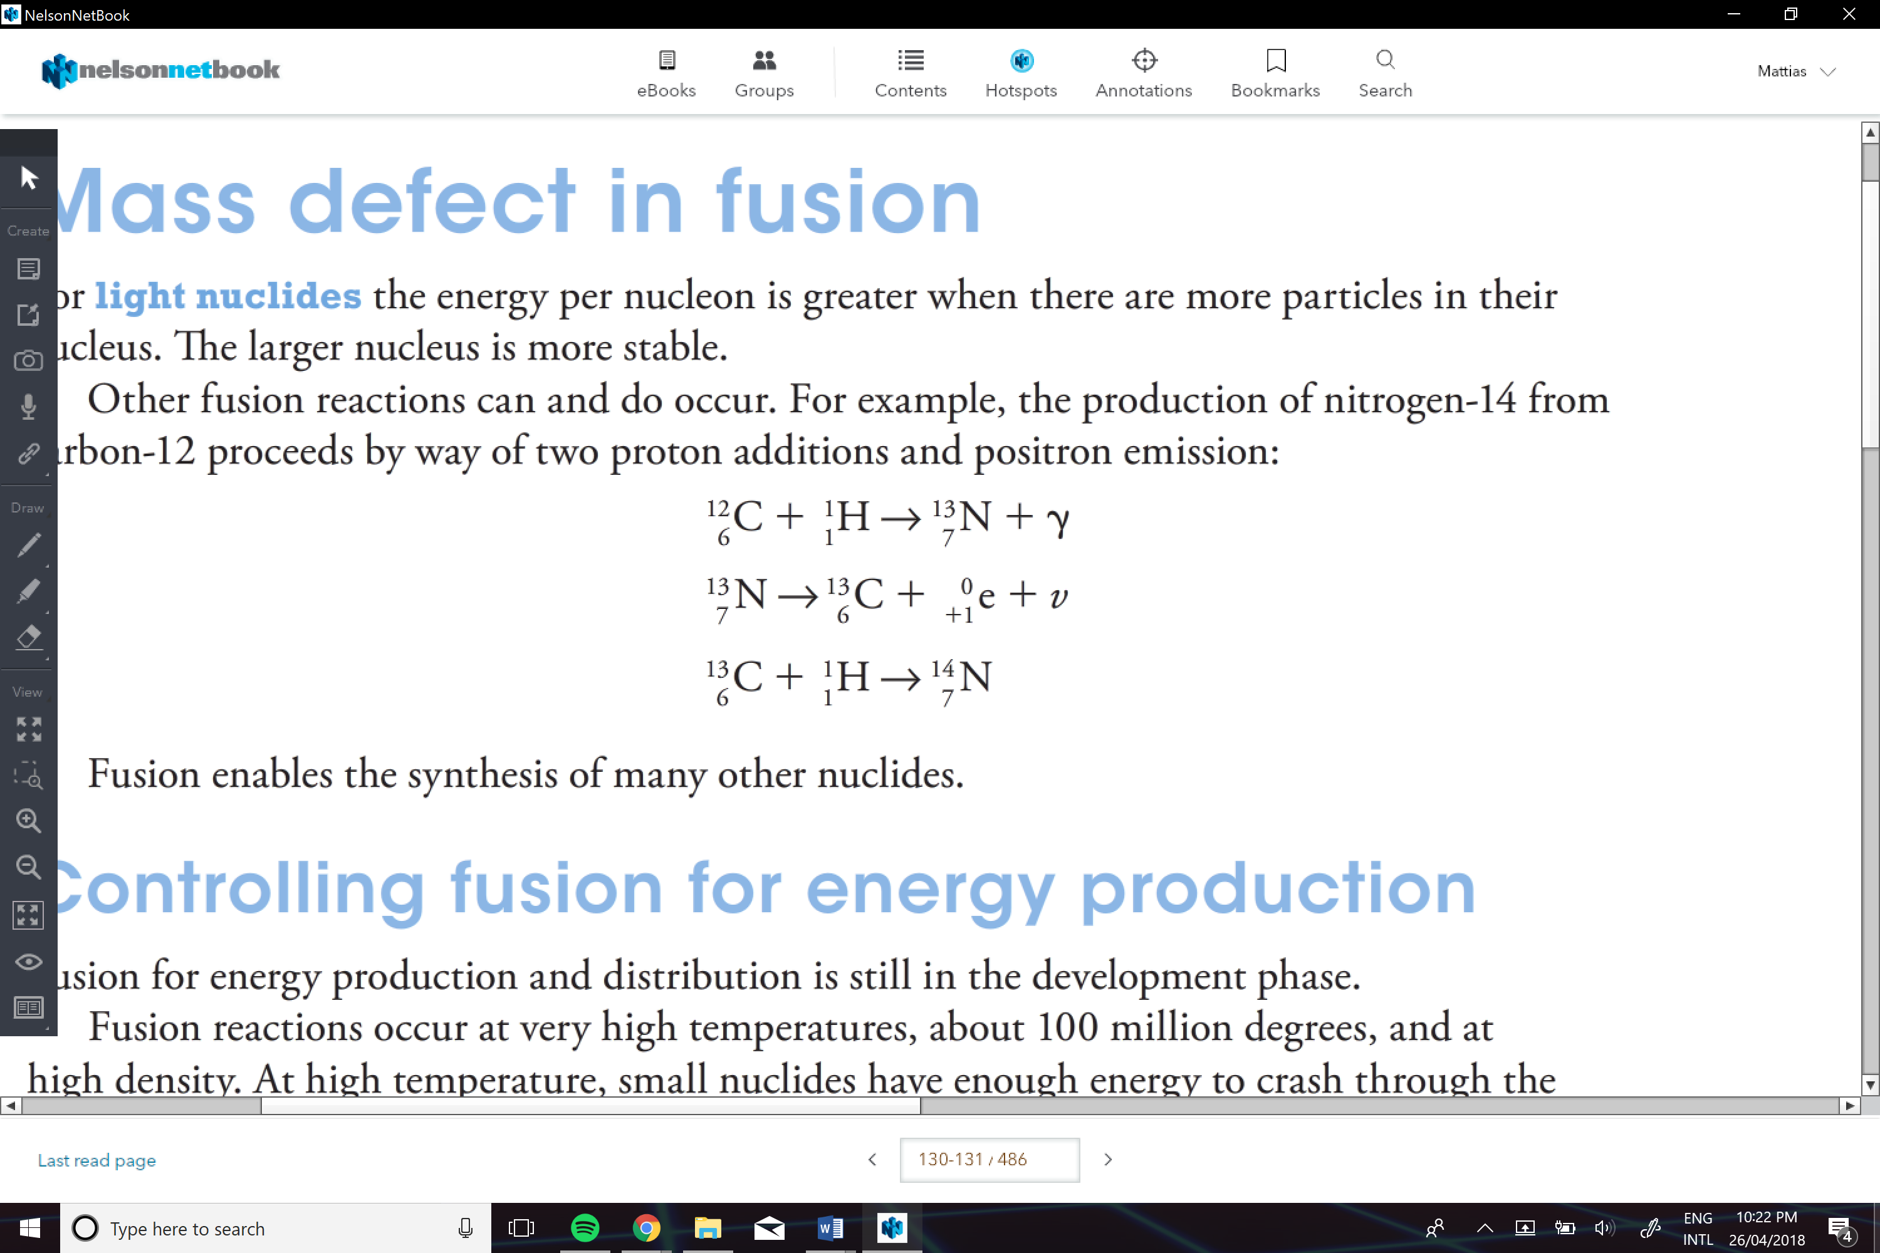

**Effect of Radiation on Humans:**

Absorbed Dose (D):

Is the energy arriving at the body unit off mass

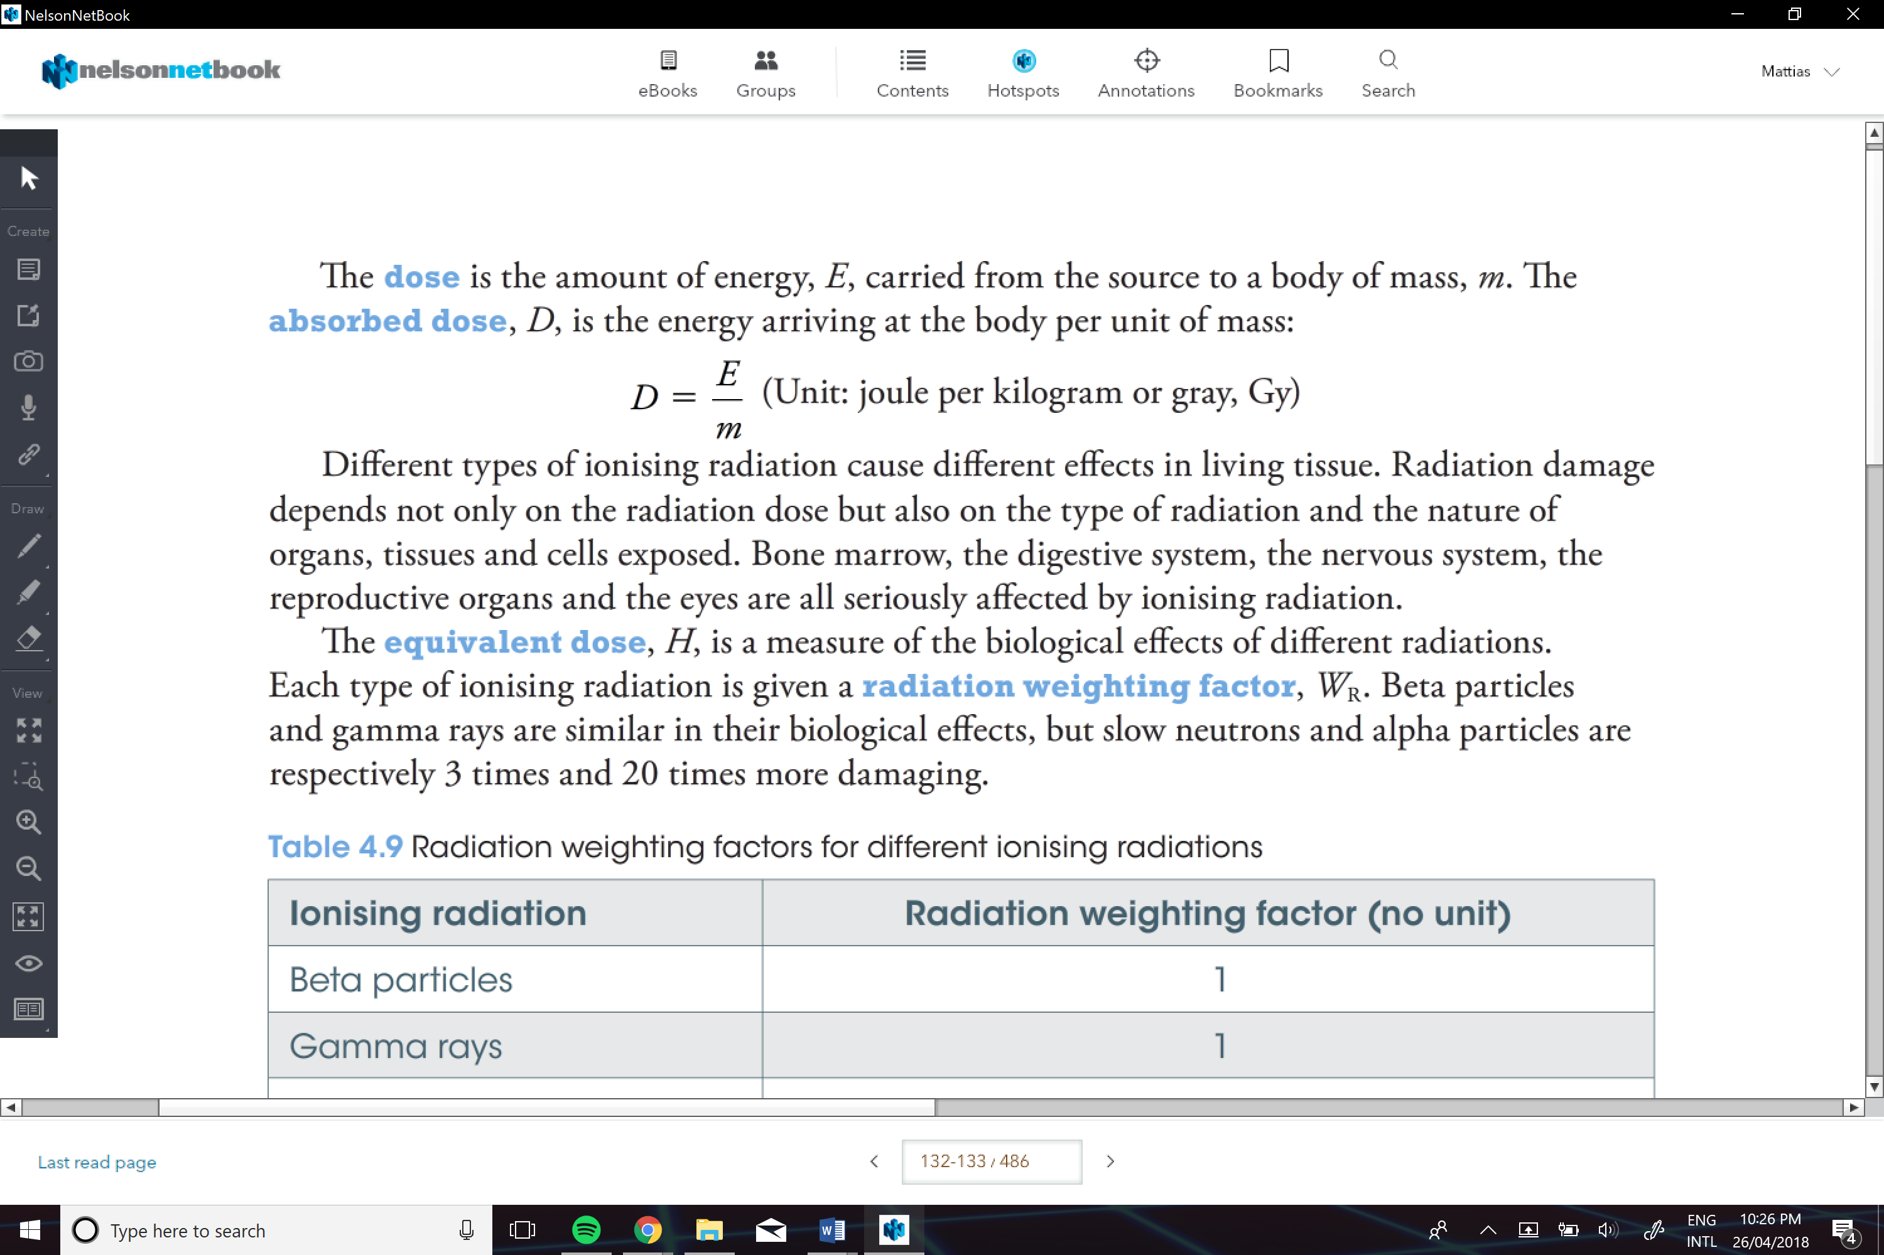

Equivalent Dose (*H*)

Is a measure able of the biological effects of different radiations.

